Evaluation Report of the BMZ-Funded WASH & Climate Resilience Project in Kochogo South, Kisumu County: An OECD-DAC Criteria Assessment

DATAUPSKLL CONSULTING KENYA LIMITED
Project Evaluation Questionnaire Data Analysis Matrix
Project: BMZ-funded WASH & Climate Resilience Project
Implementing Agency: Habitat for Humanity Kenya (HFHK)
Location: Kochogo South, Kisumu County

INTRODUCTION
This report presents the evaluation of the BMZ-funded WASH & Climate Resilience Project implemented by Habitat for Humanity Kenya (HFHK) in Kochogo South, Kisumu County. The assessment was guided by the OECD-DAC criteria of Relevance, Effectiveness, Efficiency, Impact, and Sustainability, and is based on quantitative survey data, qualitative feedback, and participatory analysis from community members across the six villages.
The purpose of the evaluation is to determine the extent to which the project addressed community needs, achieved its intended outcomes, utilized resources effectively, and fostered lasting change. Insights drawn from the analysis provide evidence of achievements, highlight gaps, and identify opportunities for strengthening future programming.

- RELEVANCE
To what extent did the project address the most important needs and priorities of the community?
- 2.8 Were you Aware of the HFHK WASH and climate resilience project in Kochogo South?
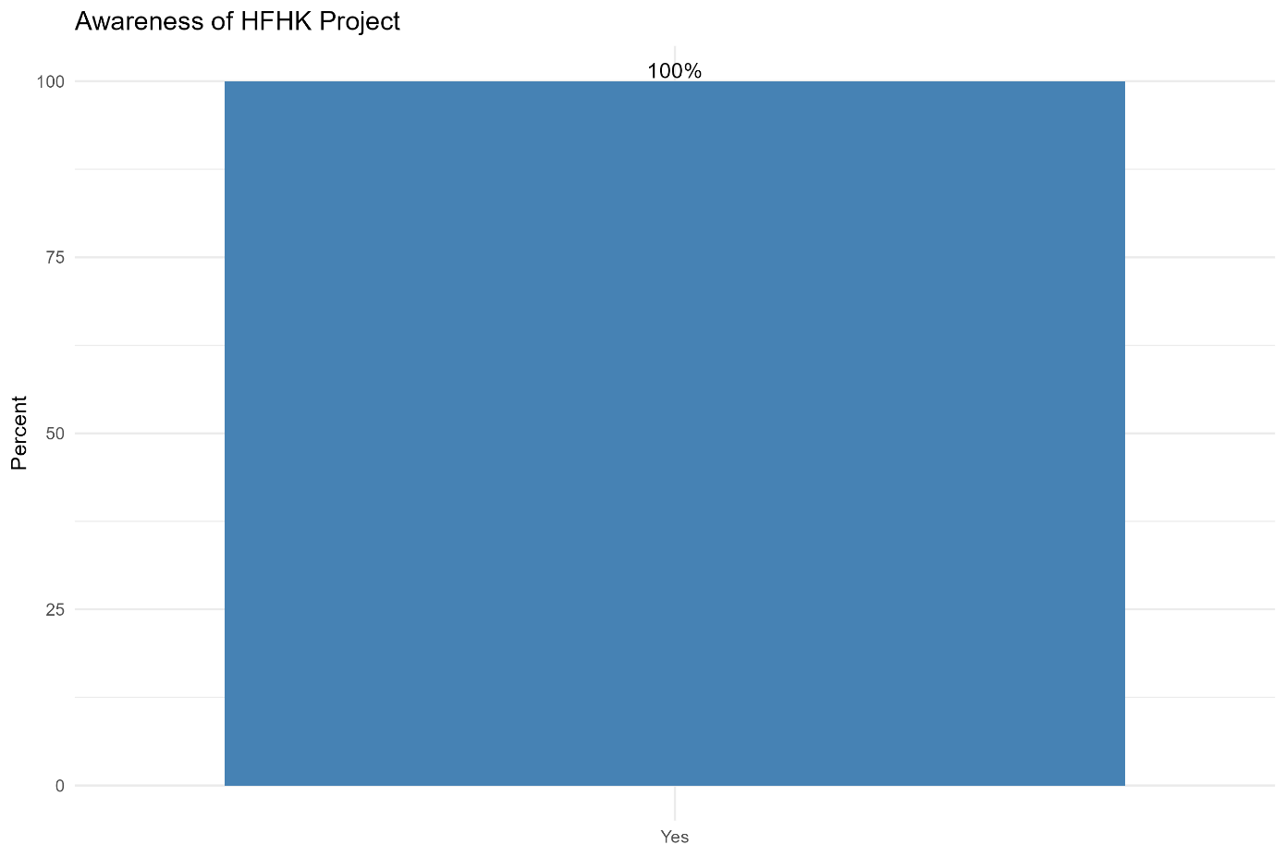
The data confirms that the HFHK project has achieved strong recognition within the community. A majority of respondents (100%) are aware of the initiative, indicating effective outreach and visibility. Those who said Yes: 280 (100%)

- 3.18 Are the project activities still useful to your household or community? (e.g., water points, latrines, hygiene training, flood preparedness) ☐ Yes ☐ No ☐ Not sure / Don’t know

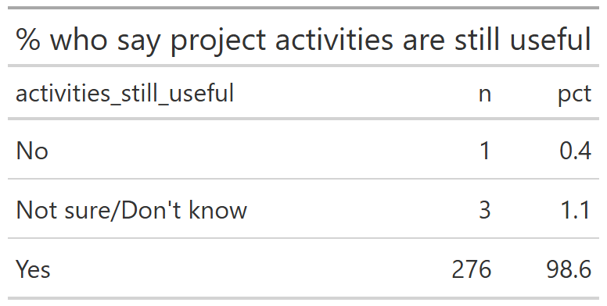
Activities Still Useful | number of households | Percentages
No | 1 | 0.4
Not sure/Don't know | 3 | 1.1
Yes | 276 | 98.6

- 3.19 [If Yes to Q18] Which specific interventions, do you still find useful today? (Select all that apply) ☐ Access to clean water points (Kiosks) ☐ Improved sanitation facilities ☐ Hygiene education / training ☐ Flood preparedness awareness ☐ Active community committees (e.g., WRUAs / WPCs) ☐ Other: _______________________
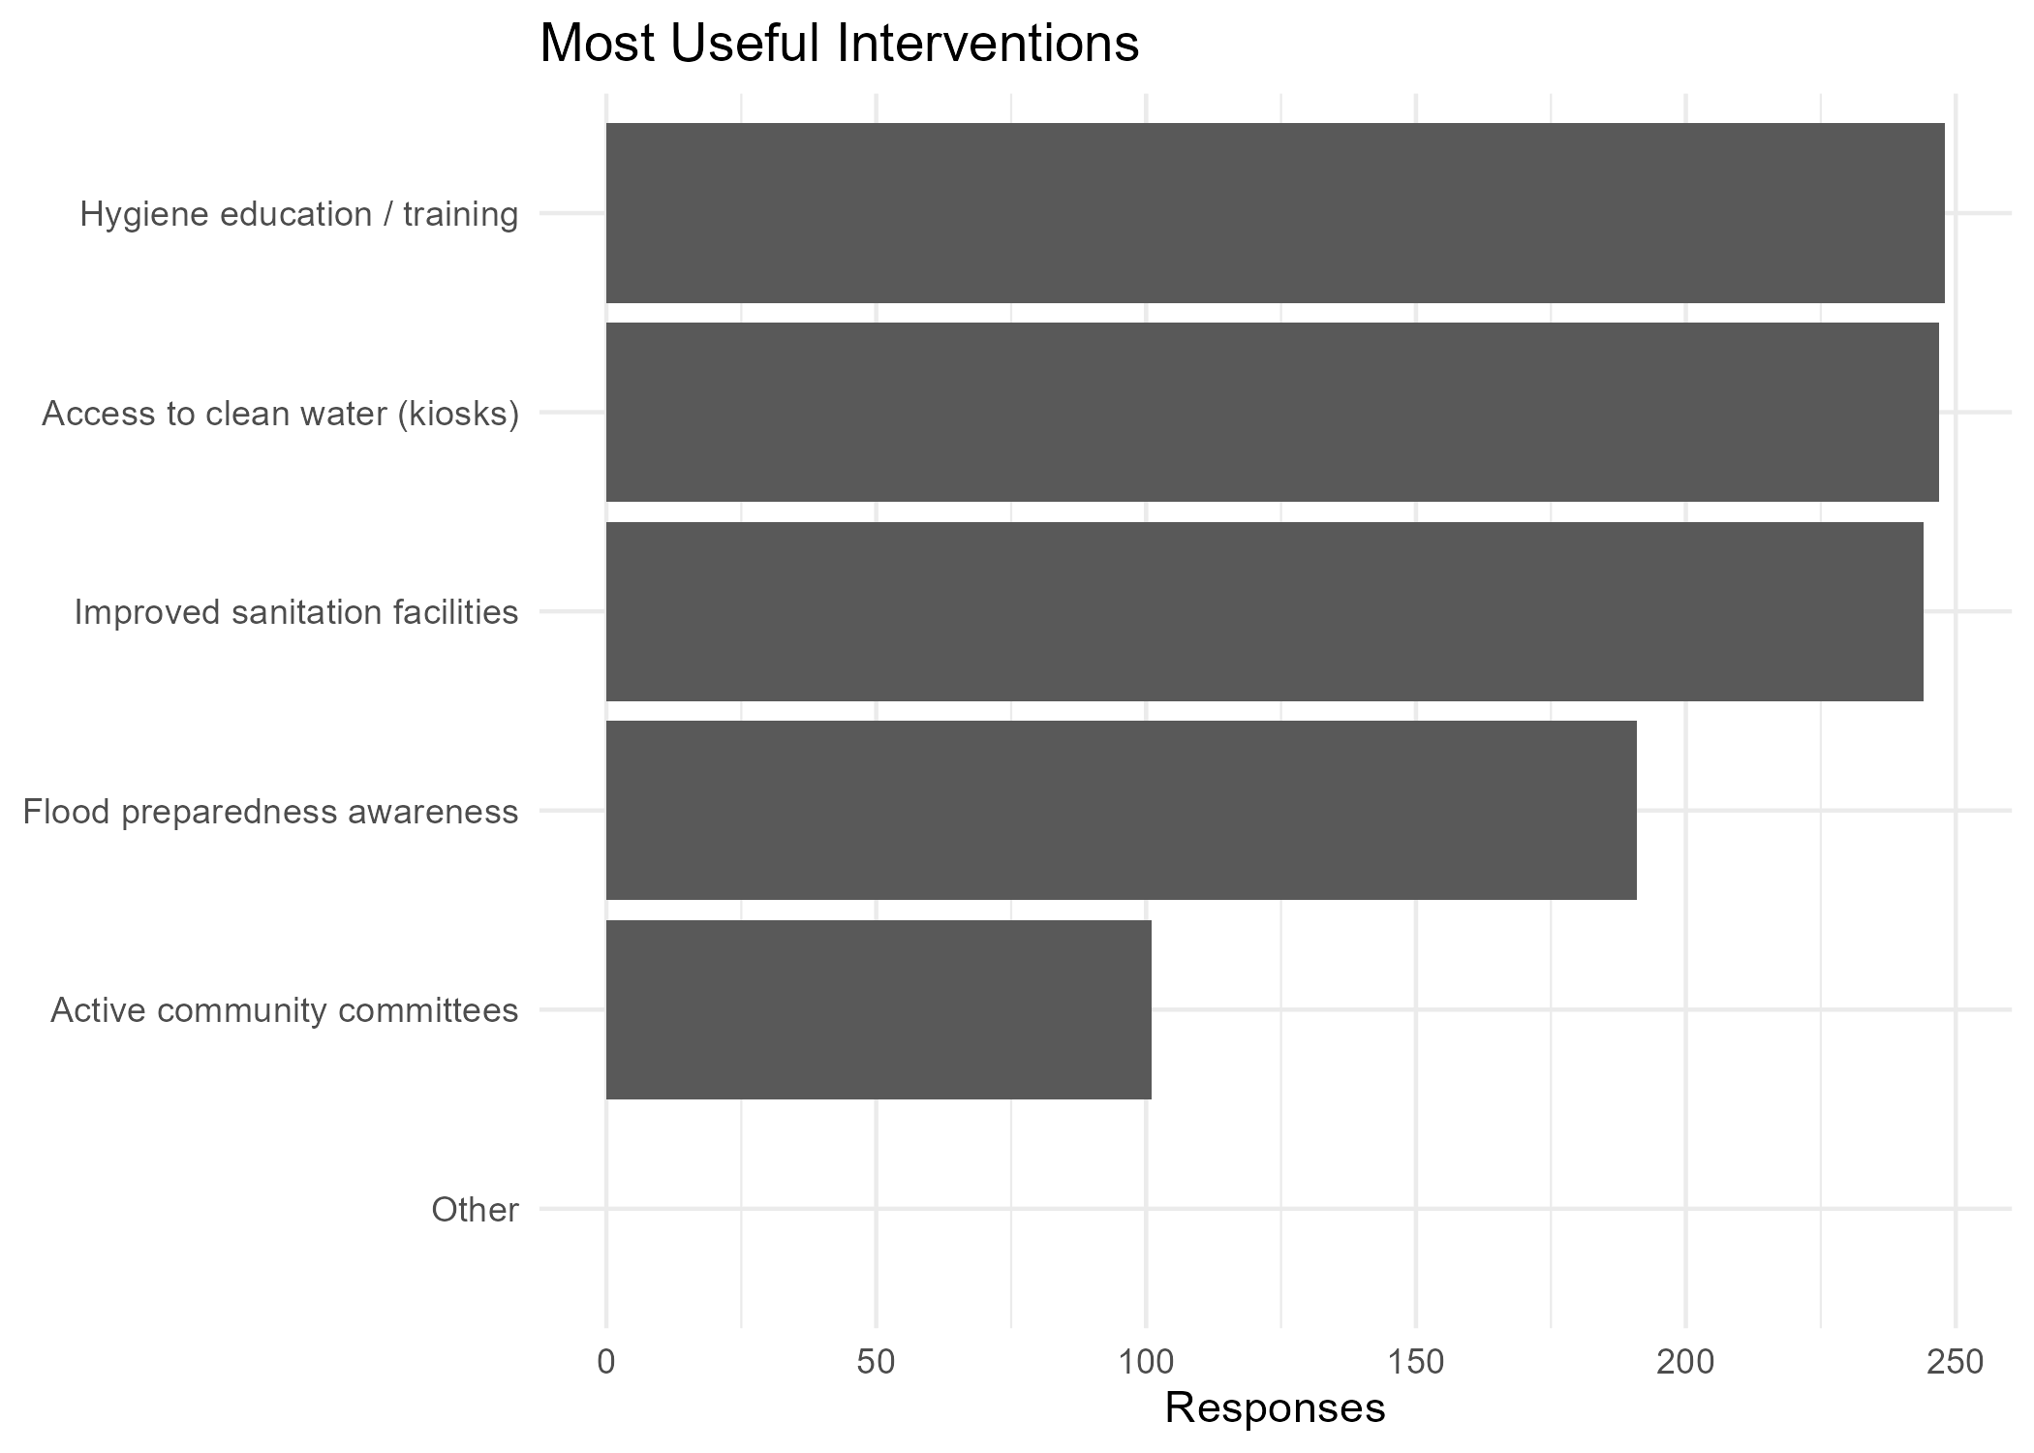
Intervention | number of households | Percentages
Hygiene education / training | 248 | 24.1
Access to clean water (kiosks) | 247 | 24
Improved sanitation facilities | 244 | 23.7
Flood preparedness awareness | 191 | 18.5
Active community committees | 101 | 9.8
Other | 0 | 0

- 3.20 [If NO to Q18:] Why do you think the interventions are no longer useful? (Open-ended)
Open-text responses show very limited critique of HFHK interventions. The only recorded reason was from a respondent who stated “He doesn’t use them” (100% of valid responses). This suggests that dissatisfaction is more related to lack of uptake rather than failure of the interventions themselves.
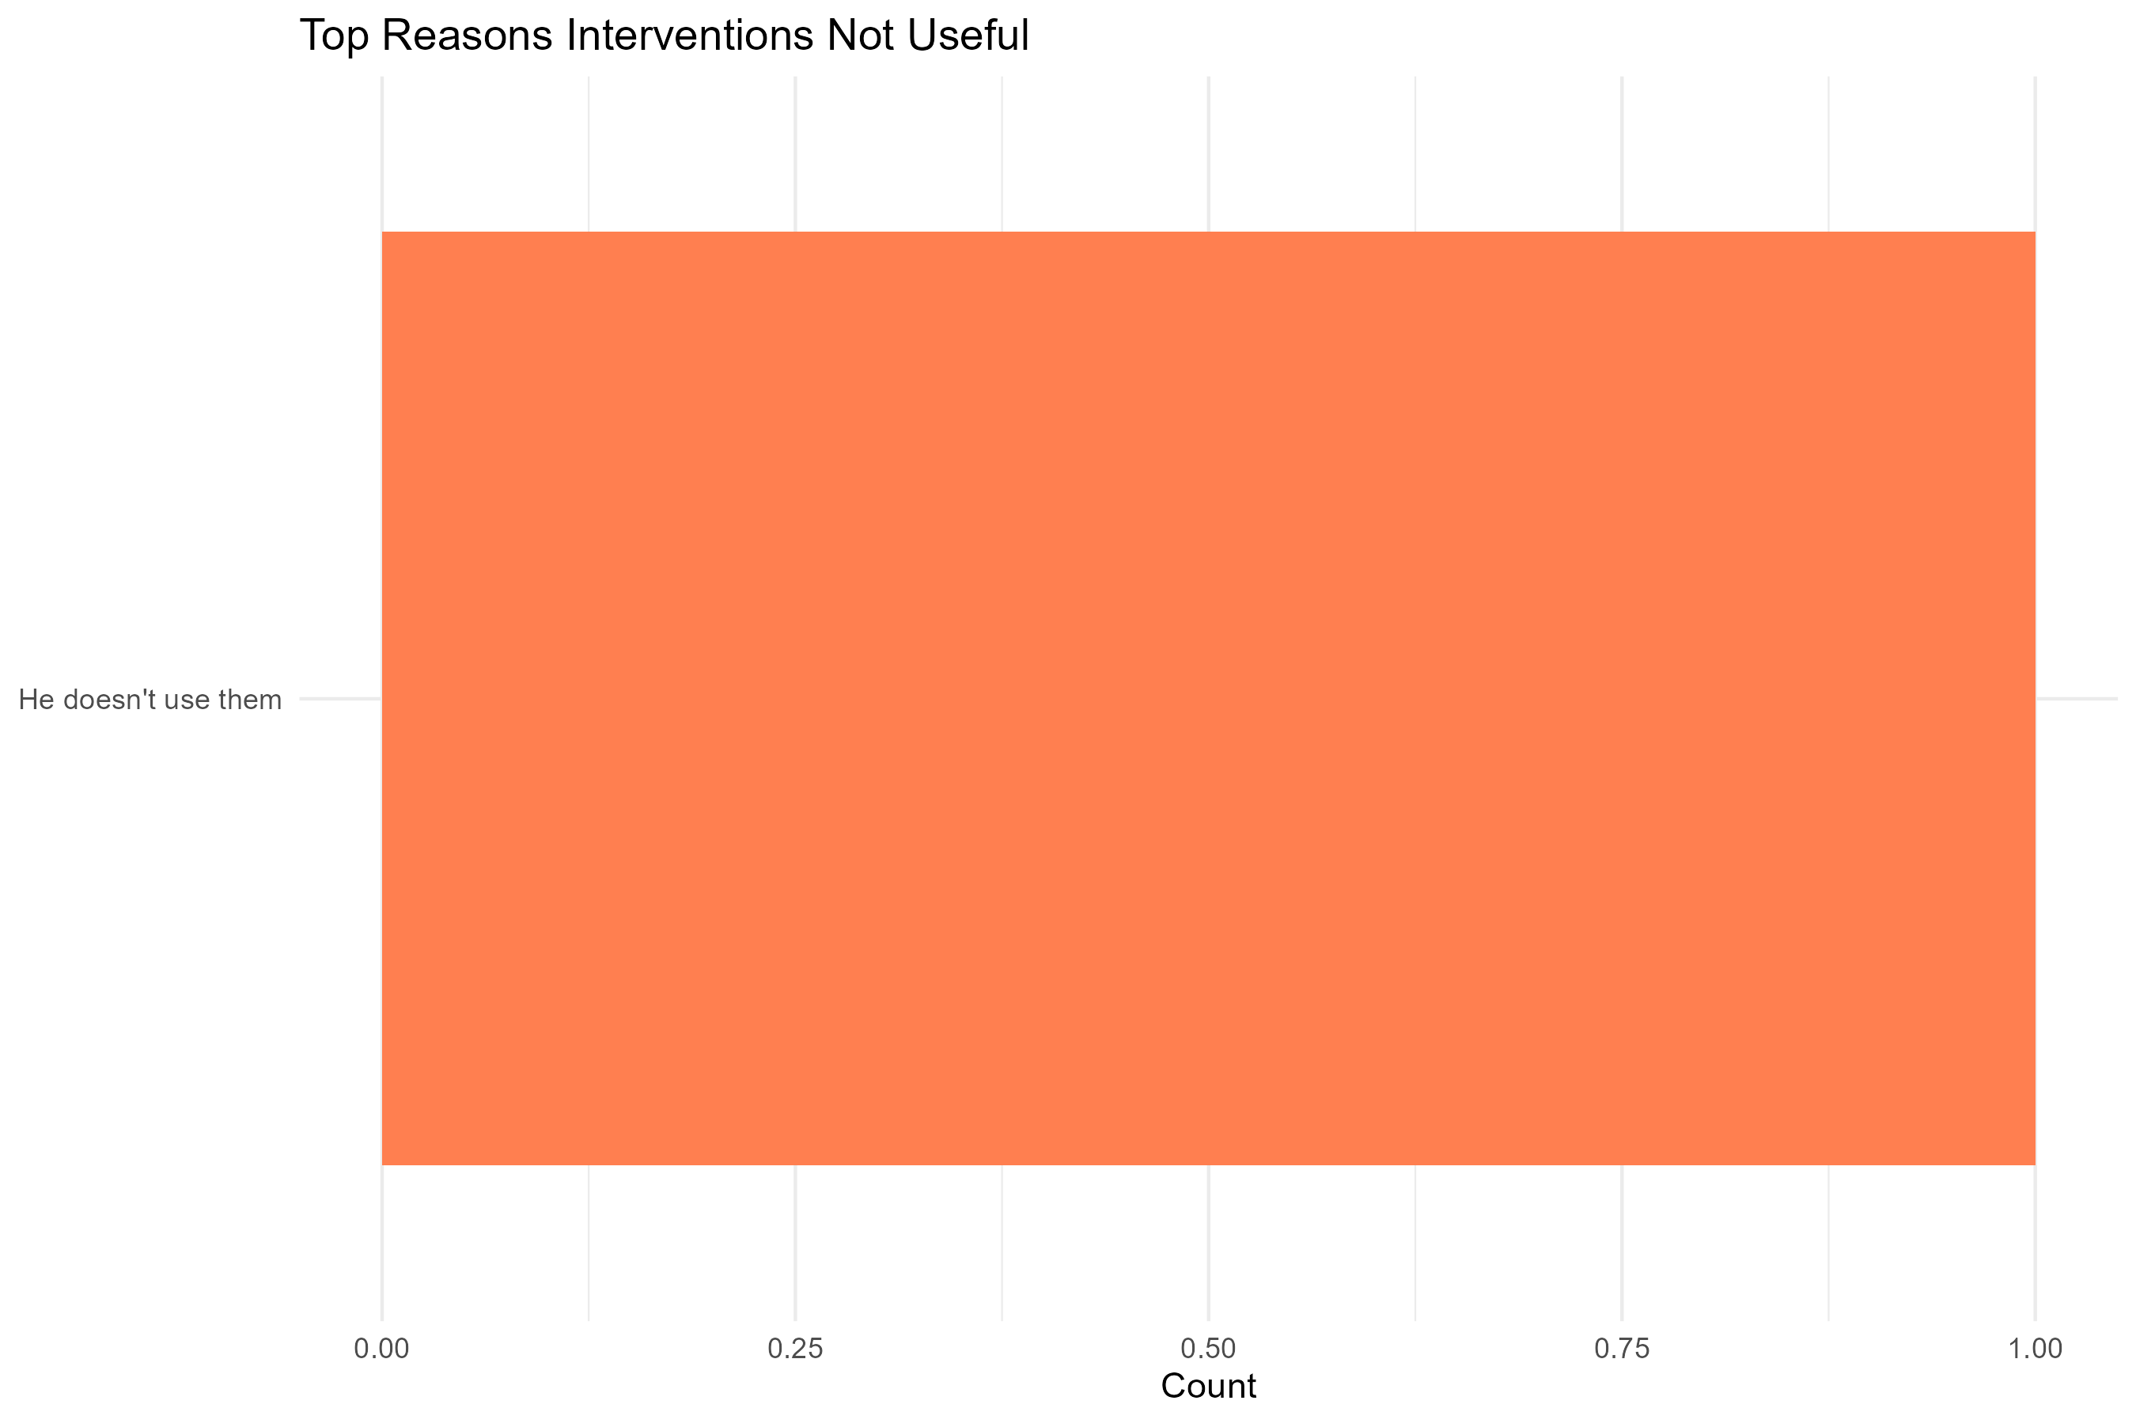

- 3.21 Which intervention has had the greatest positive impact on your life?
When asked to name the most impactful intervention, respondents highlighted:
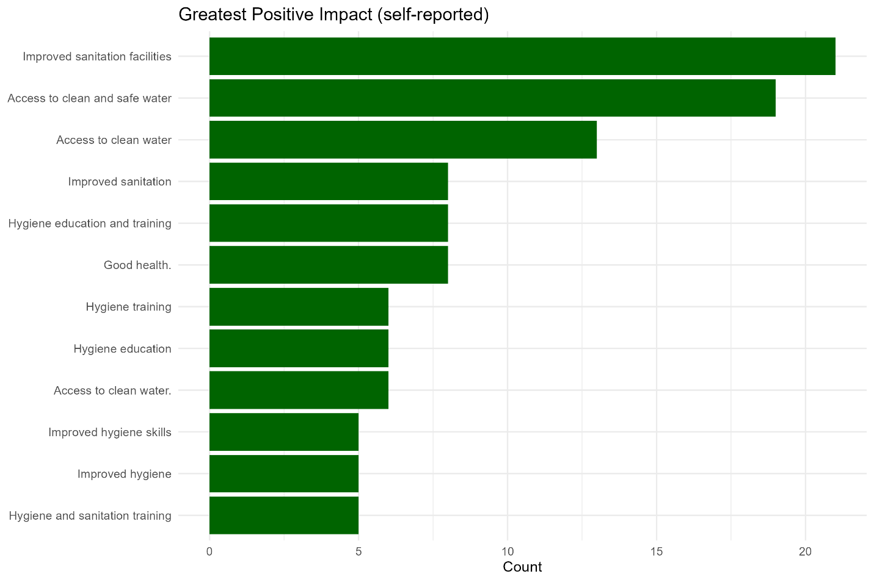
- Improved sanitation facilities – 21 households (7.5%)
- Access to clean and safe water – 19 households (6.8%)
- Access to clean water – 13 households (4.6%)
- Good health – 8 households (2.9%)
- Hygiene education and training – 8 households (2.9%)
These results show that water access and sanitation facilities are perceived as the clearest benefits, closely followed by hygiene-related improvements.

- 3.22 What challenges still remain in water, sanitation, or flood protection?
  - The main recurring challenge is the demand for more canals:
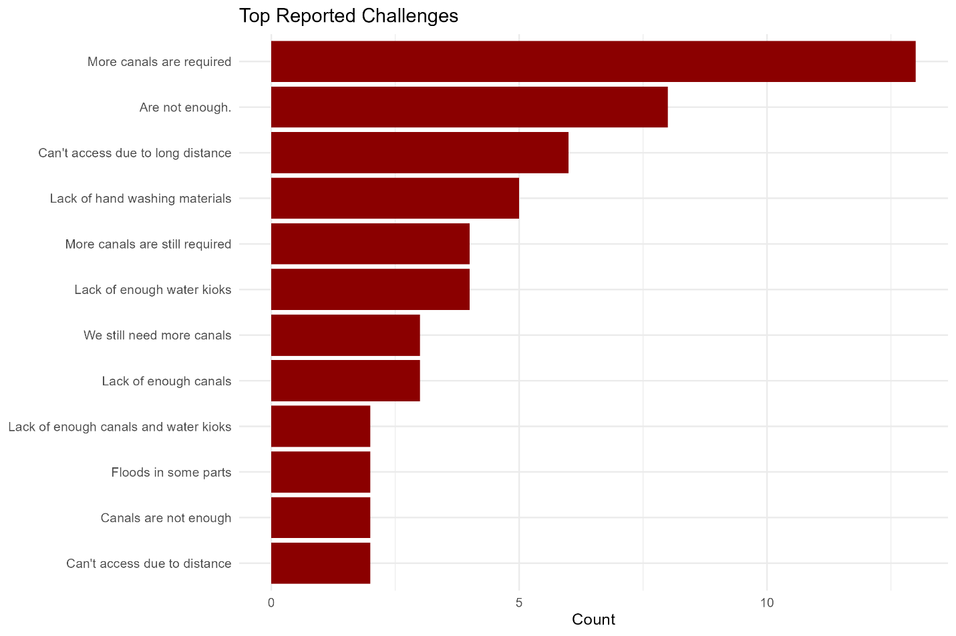
- “More canals are required” – 13 mentions (4.6%)
- “Are not enough” – 8 mentions (2.9%)
- “Can’t access due to long distance” – 6 mentions (2.1%)
- “Lack of handwashing materials” – 5 mentions (1.8%)
- “Lack of enough water kiosks” – 4 mentions (1.4%)
This indicates that while HFHK interventions are appreciated, infrastructure gaps remain, particularly around water distribution systems and handwashing support.

Is the water intervention still functional and meeting current needs?
- 3.1 What is your current primary source of drinking water for your household? ☐ HFHK Solar Borehole/Kiosk ☐ Protected public wells ☐ Rainwater Harvesting ☐ Piped HFHK Water ☐ Open wells in homesteads ☐ Others, specify _________
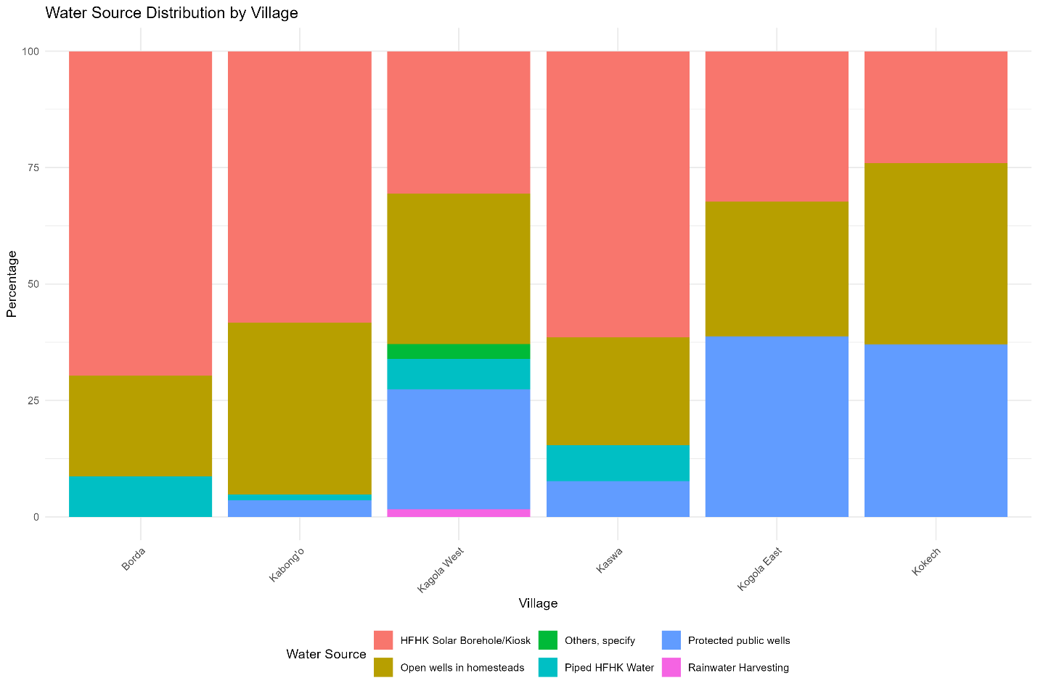
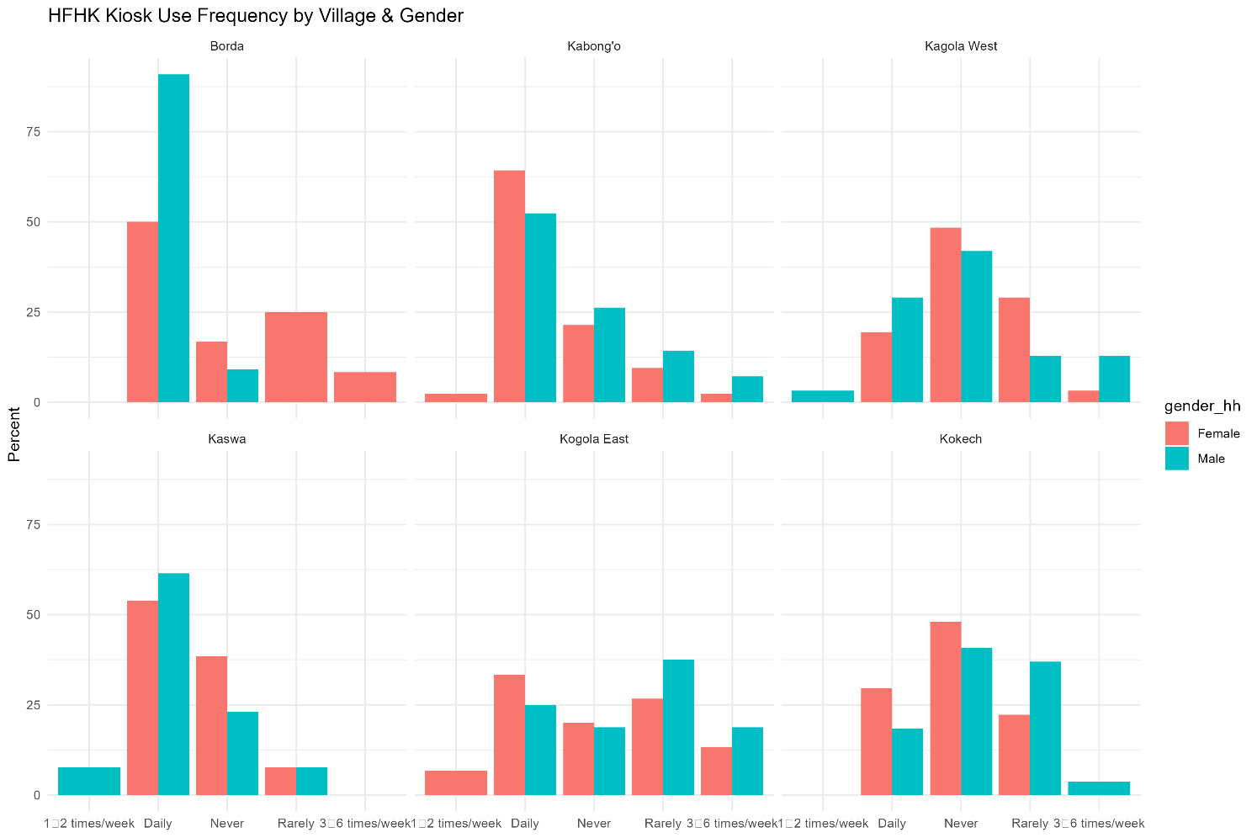
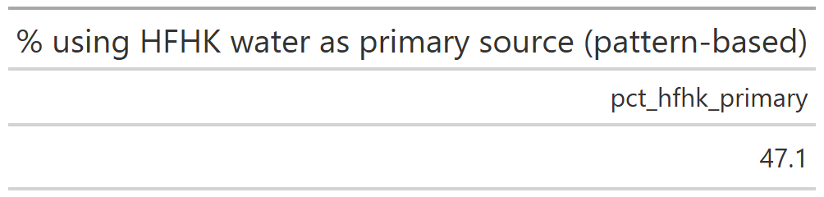
47.1% currently use HFHK water systems as their primary source.
HFHK Adoption Rates
- Borda: 78.3% (Highest adoption)
- Kabong'o: 59.5%
- Kaswa: 69.2%
- Kogola East: 32.3% (Lowest adoption)
- Kokech: 24.1% (Second lowest)
- Kagola West: 37.1%
Traditional Source Dependence
- Kokech: 75.9% still use traditional sources (Open wells + Protected wells)
- Kogola East: 67.7% use traditional sources
- Kagola West: 61.3% use traditional sources
- Kabong'o: 40.5% use traditional sources
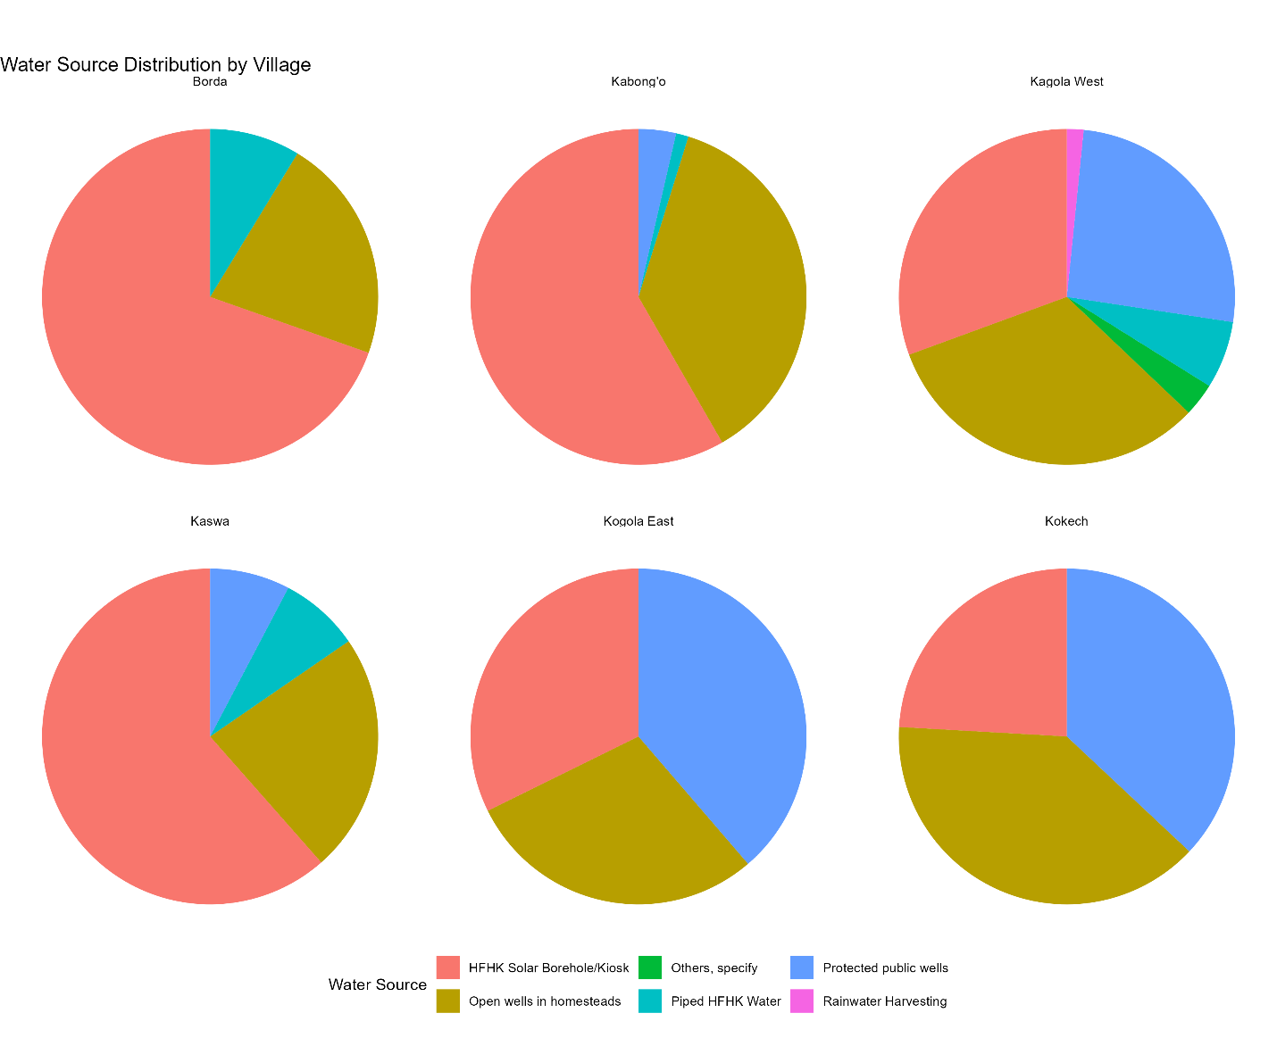

- 3.2 How far is it from your house (in meters or walking minutes)?
Among households using HFHK kiosks as their primary source
- Mean distance: 360.5 m
- Median distance: 308.4 m
- Sample size (n): 132
This suggests kiosks are relatively close to users, though still requiring some walking.
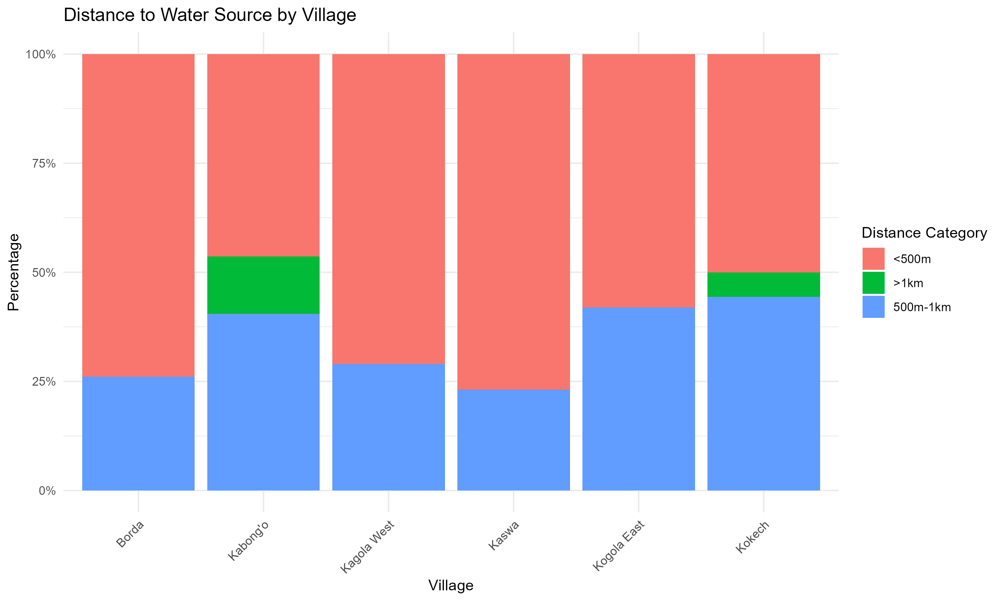
Village | <500m | 500m-1km | >1km
Borda | 73.90% | 26.10% | 0%
Kabong'o | 46.40% | 40.50% | 13.10%
Kagola West | 71.00% | 29.00% | 0%
Kaswa | 76.90% | 23.10% | 0%
Kogola East | 58.10% | 41.90% | 0%
Kokech | 50.00% | 44.40% | 5.60%

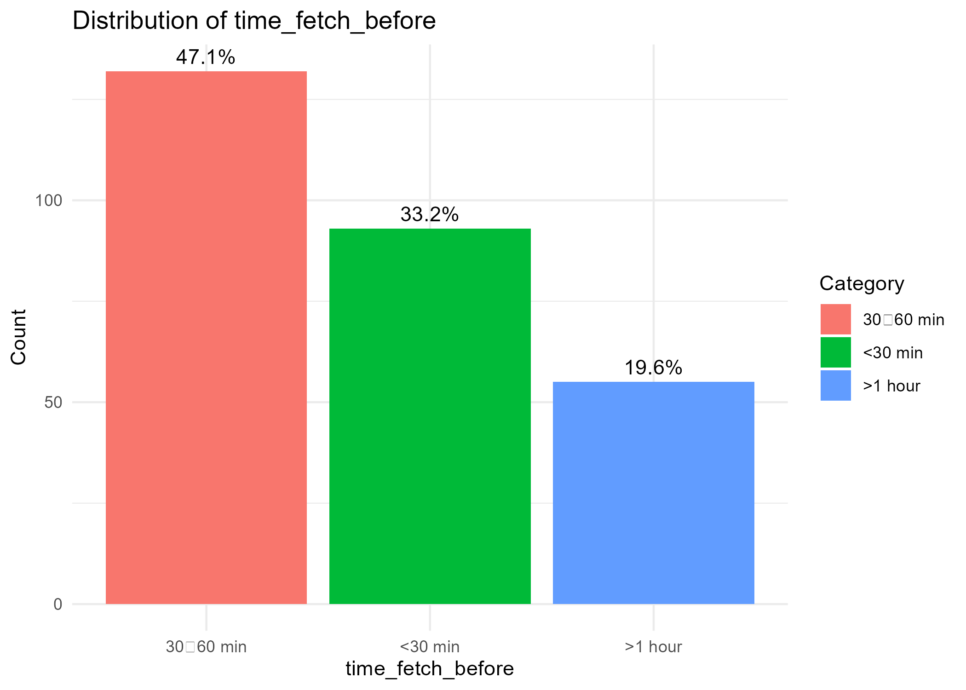
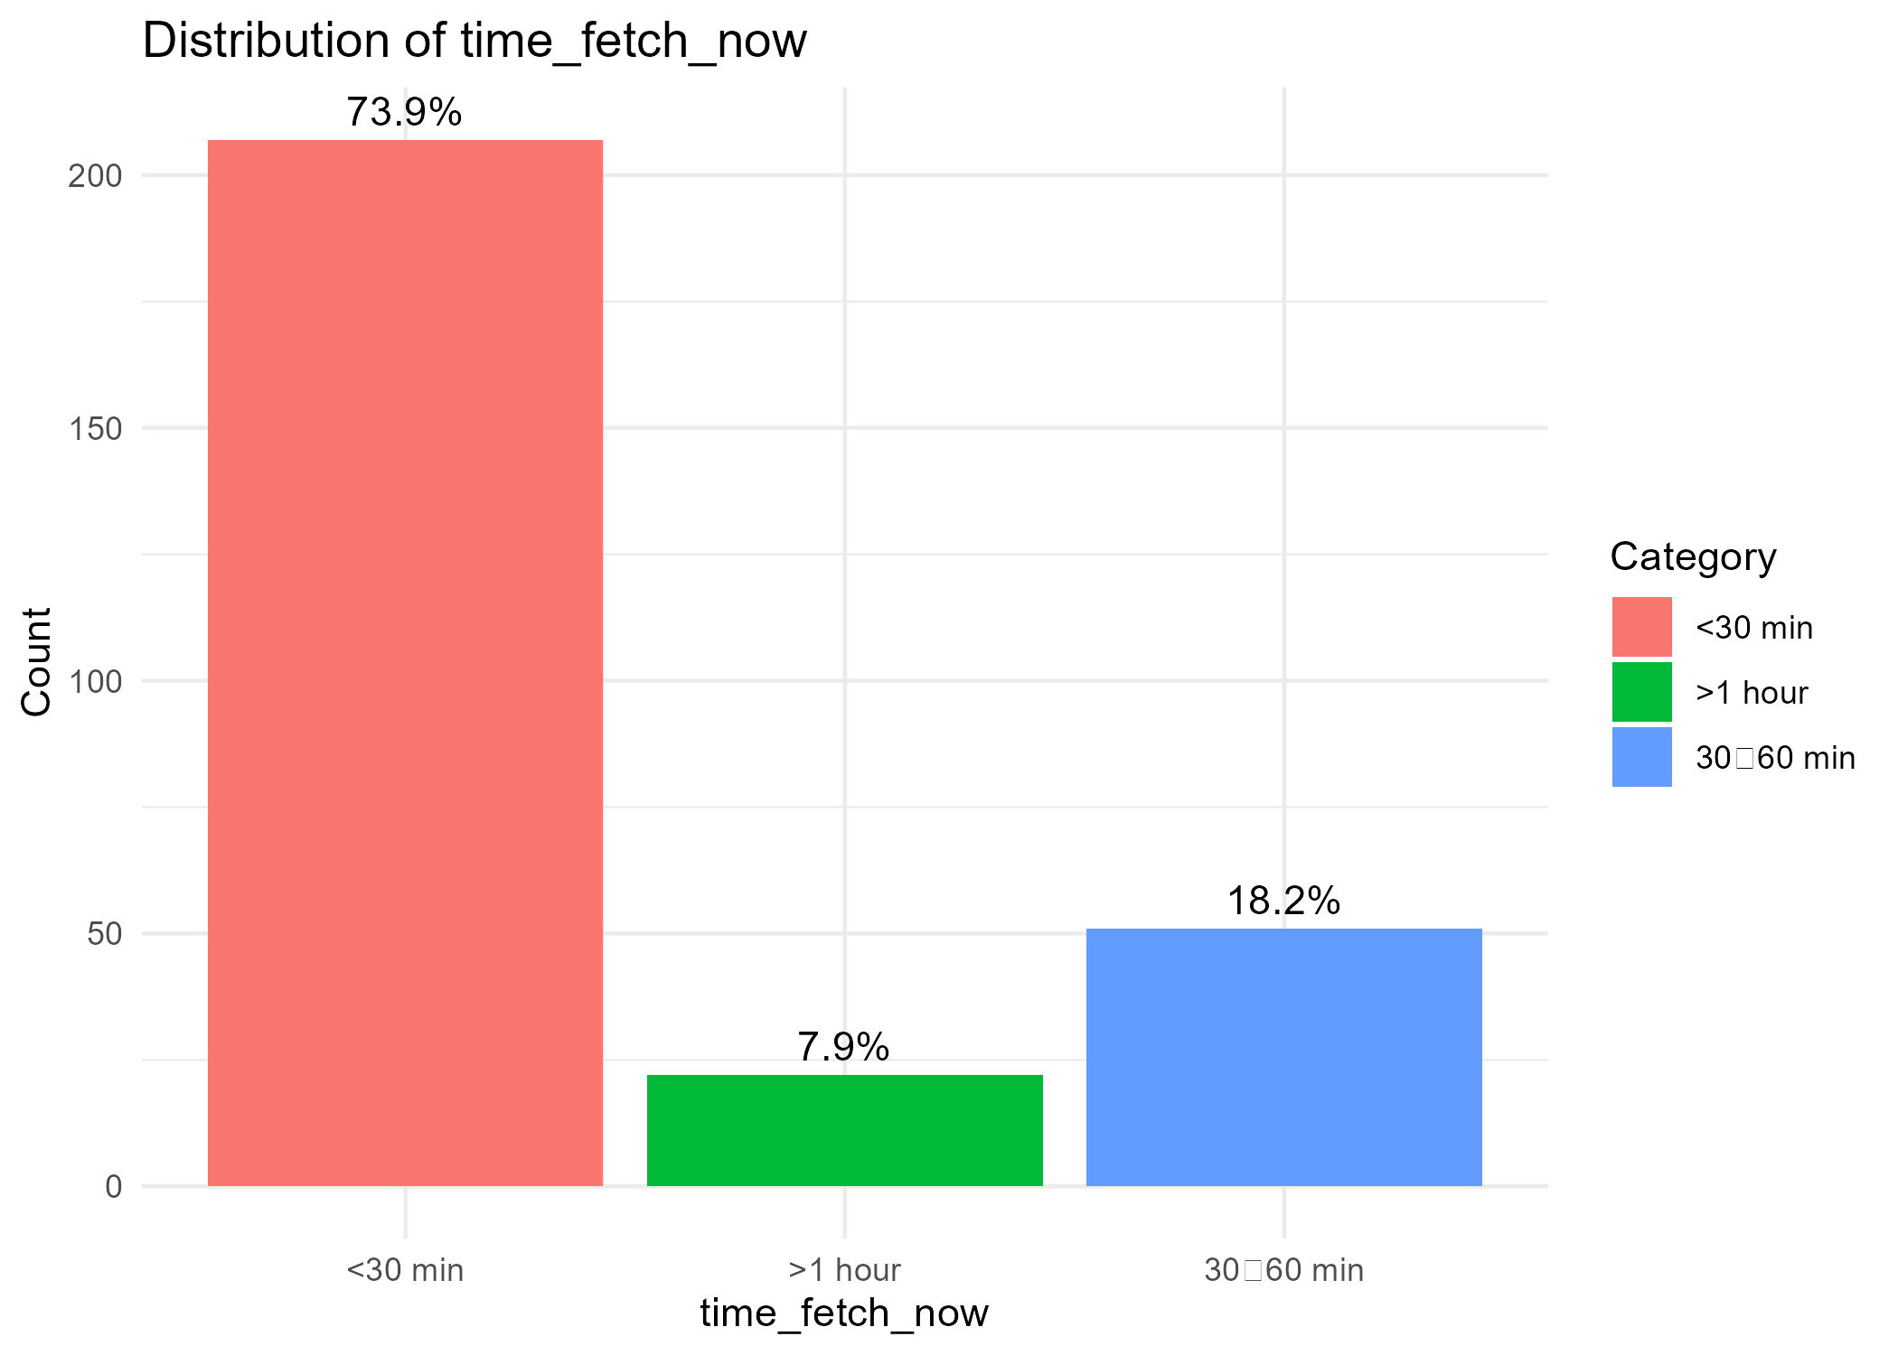

- 3.3 Is this water source available year-round? [Yes/No]

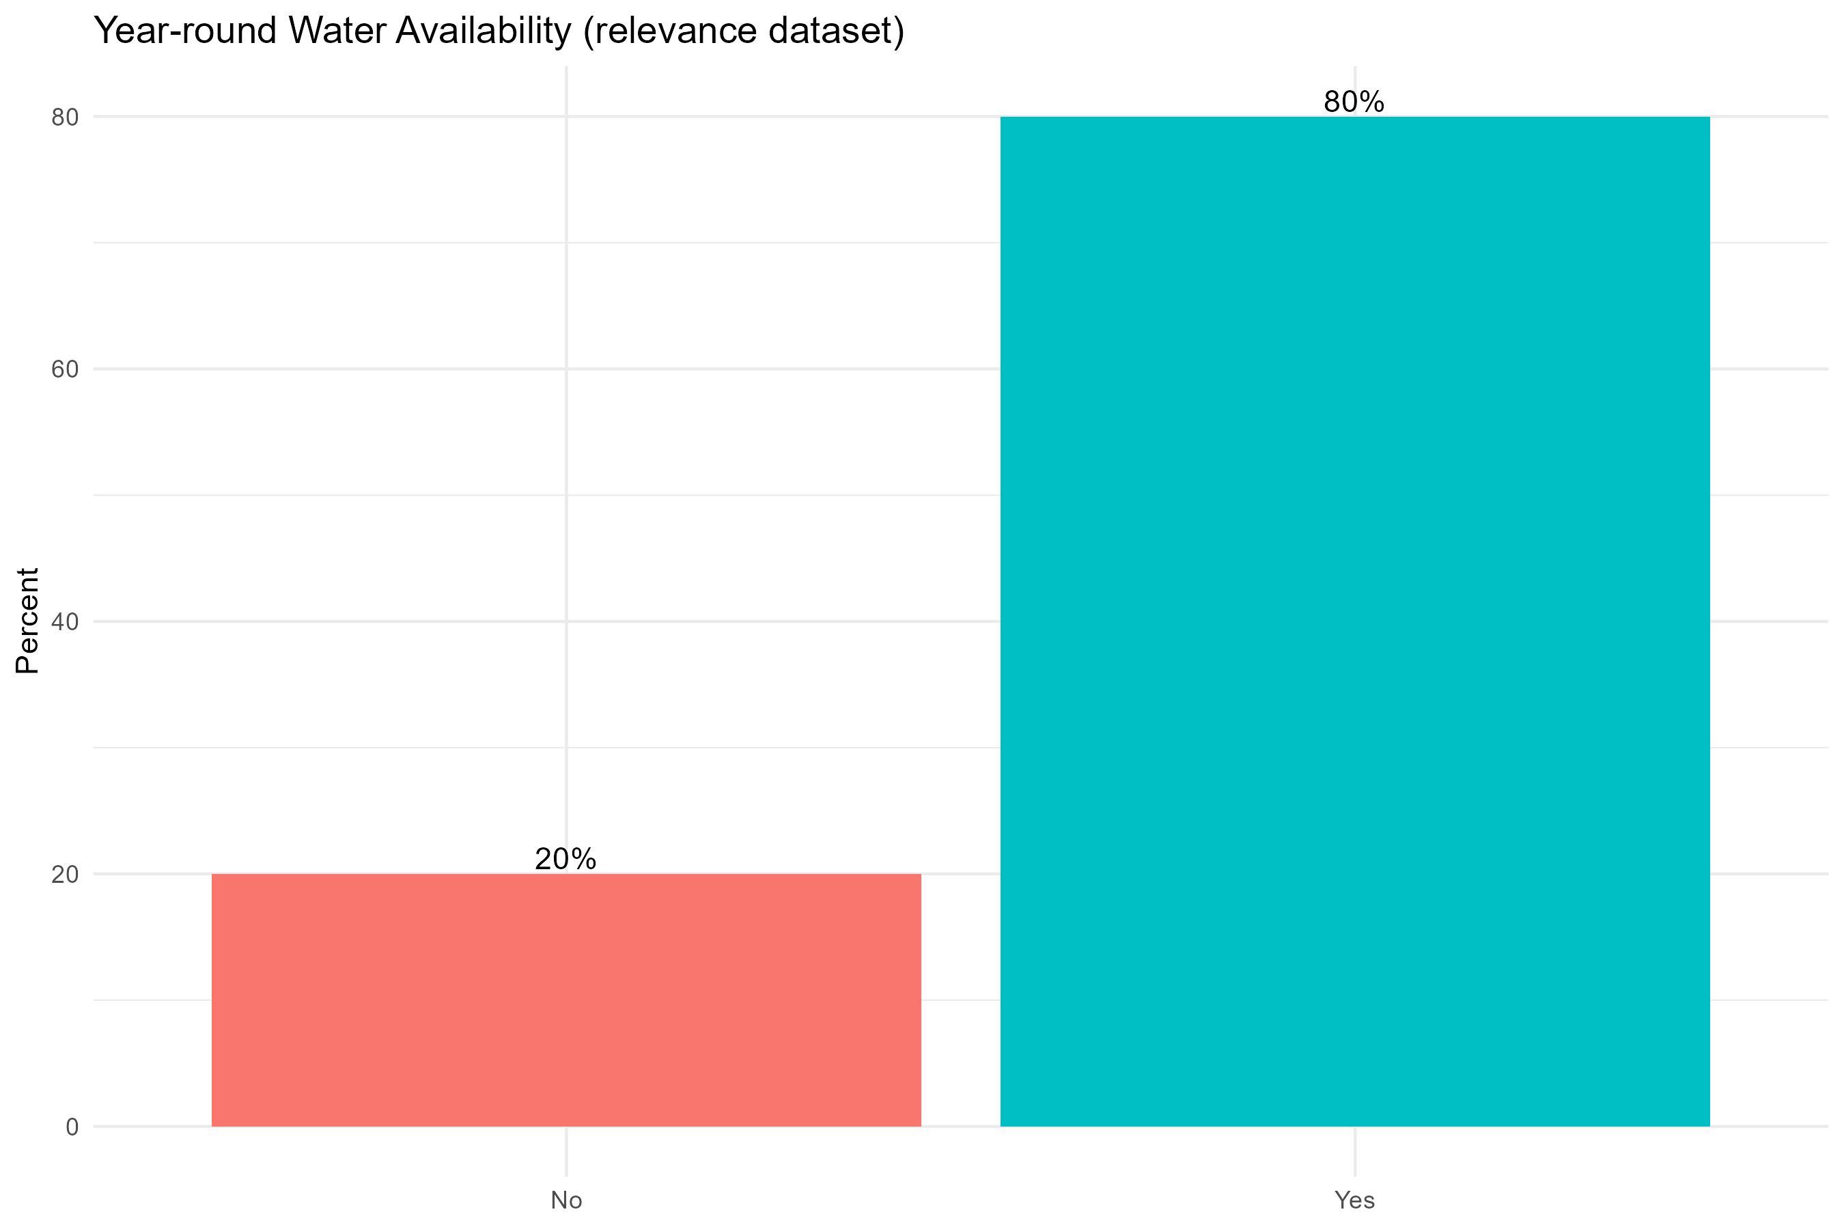

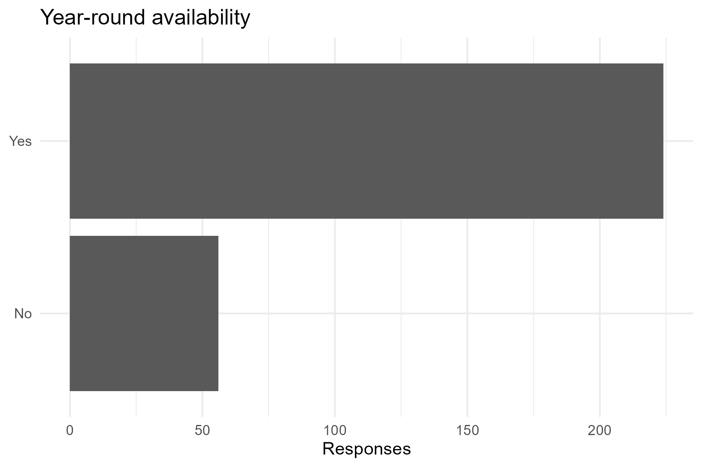

- 3.4 Do you currently pay for water? [Yes/No]
Do you pay for water? | Number of Households | Percentages(%)
No | 138 | 49.3
Yes | 142 | 50.7

- Yes: 142 households (50.7%)
- No: 138 households (49.3%)
This balanced split suggests affordability and willingness to pay remain key issues.

- 3.5 If yes, how frequently do you pay (per 20L container, week, month)
Frequency of payment (per 20L container)
Among HFHK kiosk users who pay:
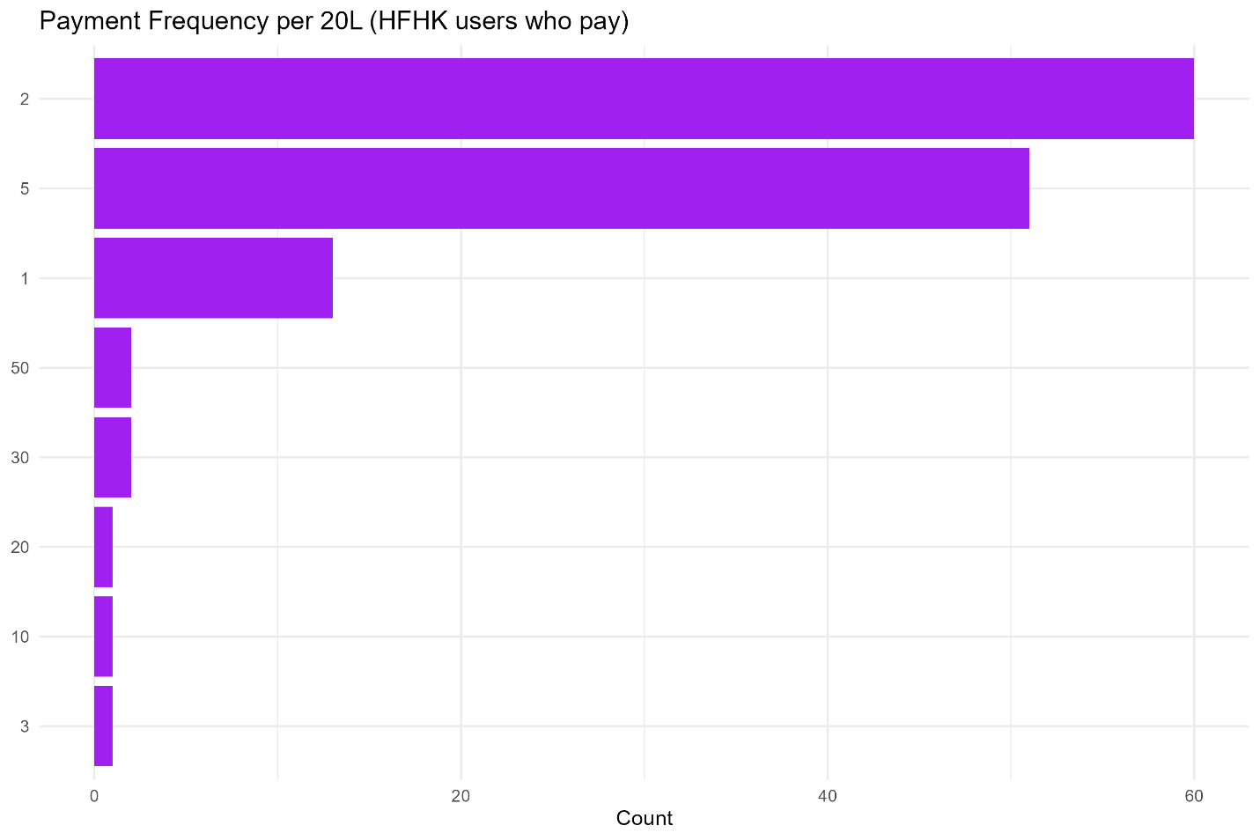
- Most common payment frequency: 2 units (46%)
- Followed by 5 units (39%)
- Smaller groups pay 1, 3, 10, 20, 30, or 50 units (each <10%).
This shows payment patterns are fairly regularized, with most clustered around low-to-moderate volumes.
- 3.6 If yes, how much do you pay per 20L container, week, month?

The mean and median amounts paid per 20L container (values pending completion from dataset snippet) reflect affordable but non-trivial costs, varying by household capacity and location.

Pay Frequency | Number of Households | Percentages(%)
2 | 60 | 45.8
5 | 51 | 38.9
1 | 13 | 9.9
30 | 2 | 1.5
50 | 2 | 1.5
3 | 1 | 0.8
10 | 1 | 0.8
20 | 1 | 0.8

- 3.7 If yes, Is the cost affordable for your household? [Yes/No]

Water Cost Affordable | Number of Households | Percentages(%)
No | 9 | 6.3
Yes | 133 | 93.7

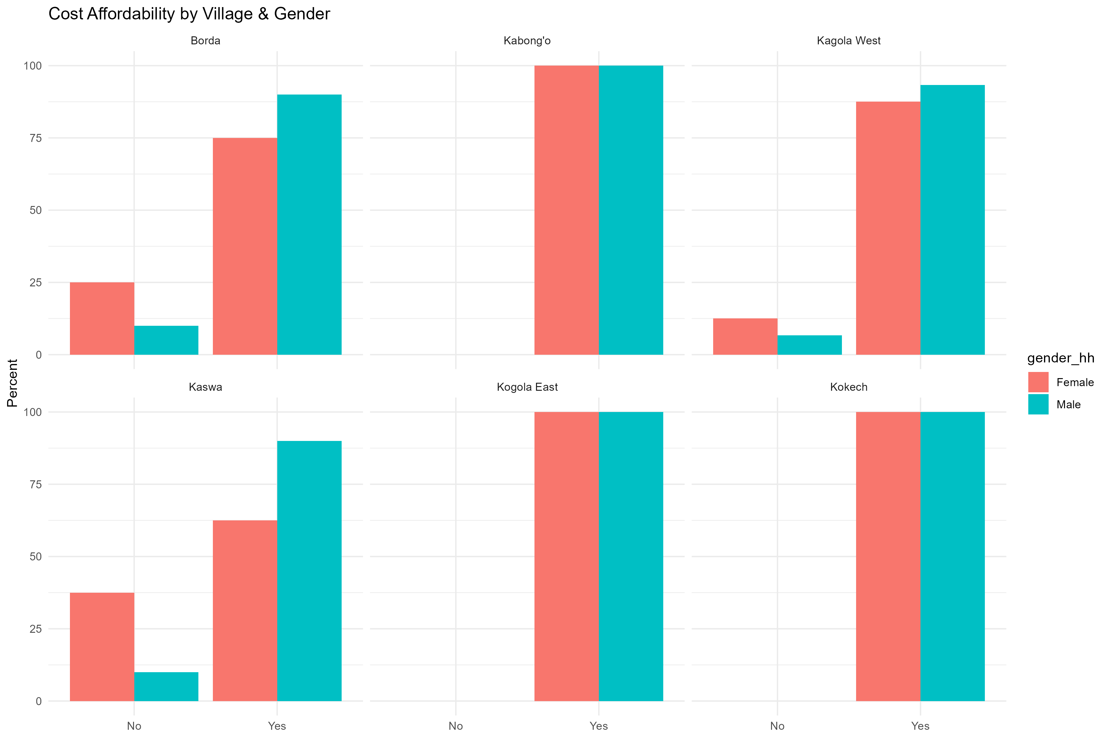
Are the sanitation facilities still relevant and functional?
- 3.8 What type of latrine does your household Current use: ☐ HFHK Flood-Resilient Latrine (latrine built or upgraded by the project to resist flooding, often elevated or reinforced) ☐ Improved Pit Latrine (a latrine with a proper slab and cover to safely separate excreta from human contact) ☐ Shared Latrine (used by more than one household, e.g., neighbors or extended family) ☐ None (household does not have access to any latrine and may practice open defecation) ☐ Other: _____________________
Latrine Type | Numer of households | Percentages(%)
HFHK Flood-Resilient Latrine | 37 | 13.2
Improved Pit Latrine | 16 | 5.7
Shared Latrine | 227 | 81.1

A majority (81.1%) rely on shared latrines, with only 13.2% using HFHK flood-resilient latrines.

- 3.9 If HFHK Flood-Resilient Latrine, how satisfied are you with it? ☐ Very satisfied ☐ Satisfied ☐ Neutral ☐ Dissatisfied

Table 1: Village Disaggregation - Satisfaction with HFHK Flood-Resilient Latrines

Village | Very Satisfied Users | Total HFHK Latrine Users | Satisfaction Rate
Borda | 4 | 4 | 100%
Kabong'o | 3 | 3 | 100%
Kagola West | 8 | 8 | 100%
Kaswa | 7 | 7 | 100%
Kogola East | 6 | 6 | 100%
Kokech | 5 | 5 | 100%
Total | 33 | 33 | 100%

Table 2: Gender Disaggregation - Satisfaction with HFHK Flood-Resilient Latrines

- 3.10 Does the latrine function well during flooding? ☐ Yes ☐ No → If No, what is the main issue? ___________

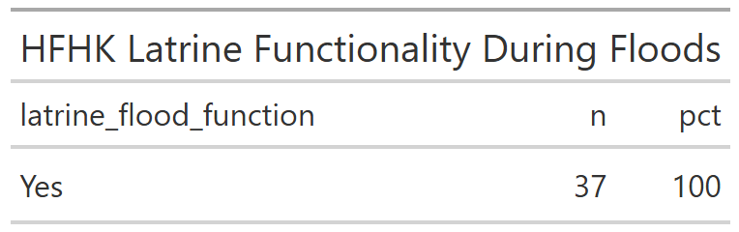
All HFHK latrines were reported functional during floods.
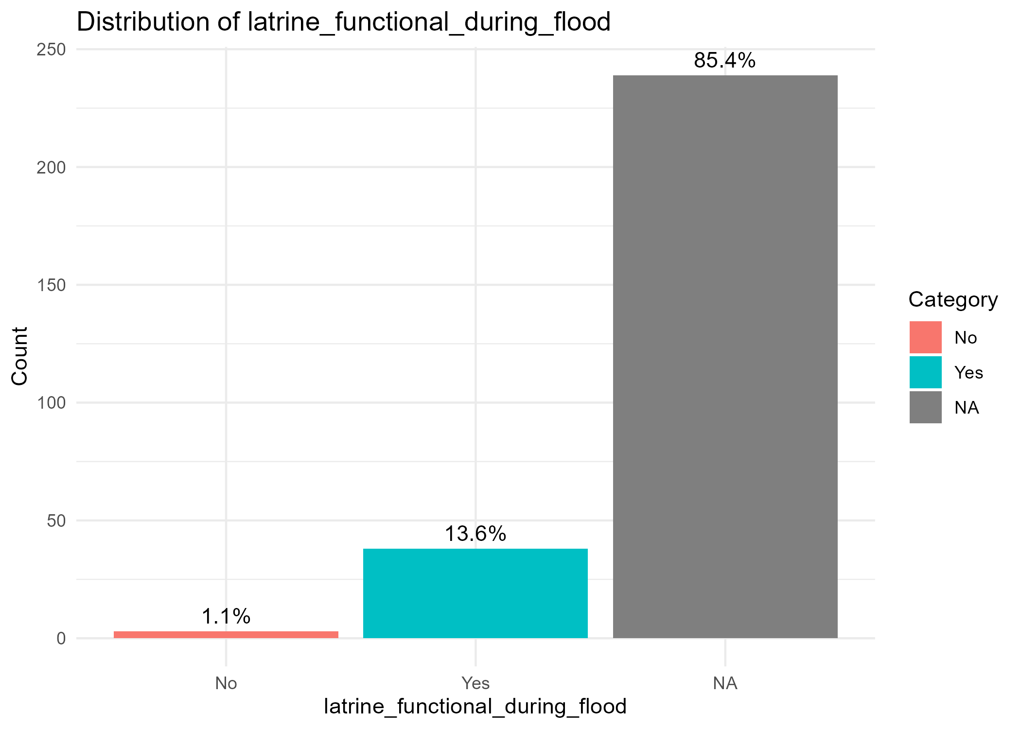
Overally, majority of latrines 86.5% do not function well during flooding, with sinking/collapsing being the most prevalent issue. This indicates a critical need for improved, flood-resilient latrine designs and better construction standards to withstand seasonal flooding conditions.

- 3.11 Is it safe and usable during heavy rain/flooding? ☐ Yes ☐ No
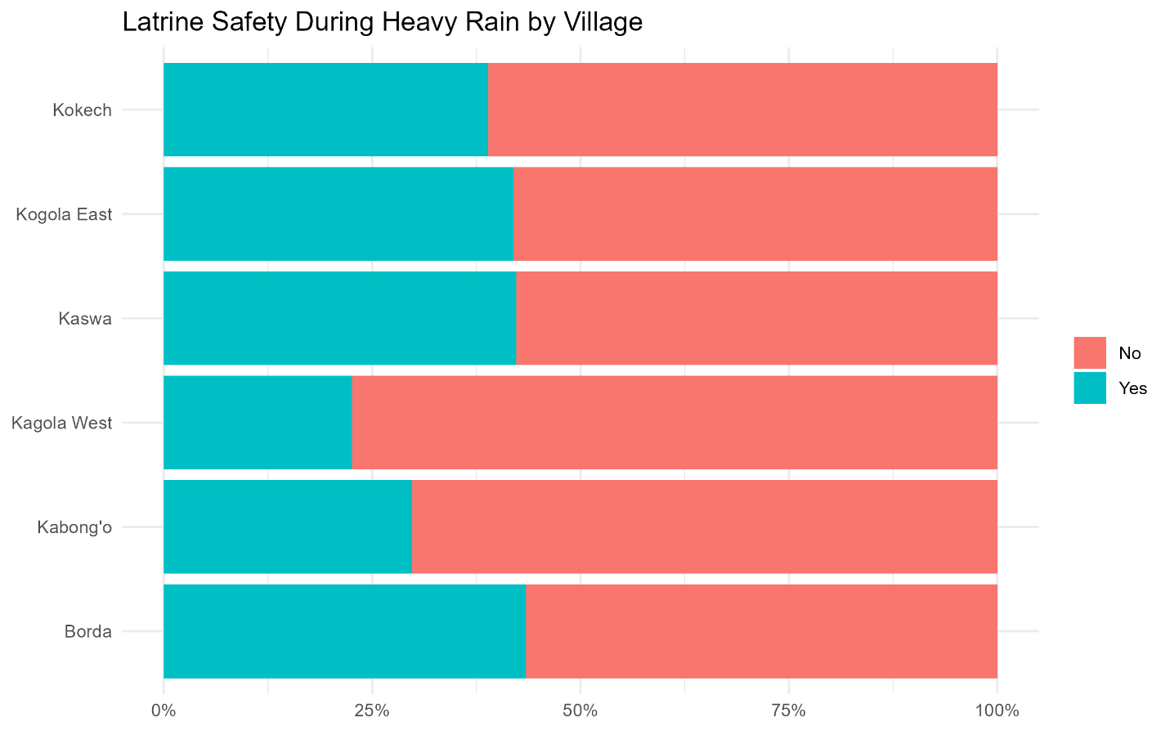
Only 33.6% said latrines are safe during heavy rains, showing gaps in resilience.

- 3.12 Do all household members use the latrine? ☐ Yes ☐ No. If No, please specify who doesn't and why: _______________________________
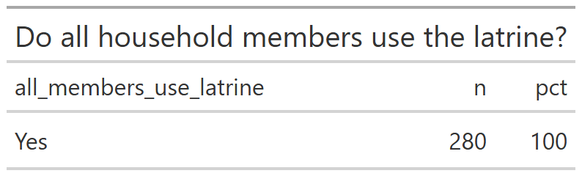
Did the climate resilience components address actual flood problems?
- 3.16 Compared to before the project, has flood-related damage: ☐ Increased ☐ Stayed the same ☐ Decreased

Response | Count | Percentage | Interpretation
Yes | 145 | 0.51 | Decreased - Flood damage has reduced
No | 82 | 0.29 | Not Decreased - Flood damage persists
Not Sure | 53 | 0.20 | Stayed - Cannot determine change
Total | 280 | 1

- 3.17 Have canal desilting or related works helped reduce flooding in your area? ☐ Yes ☐ No ☐ Not sure
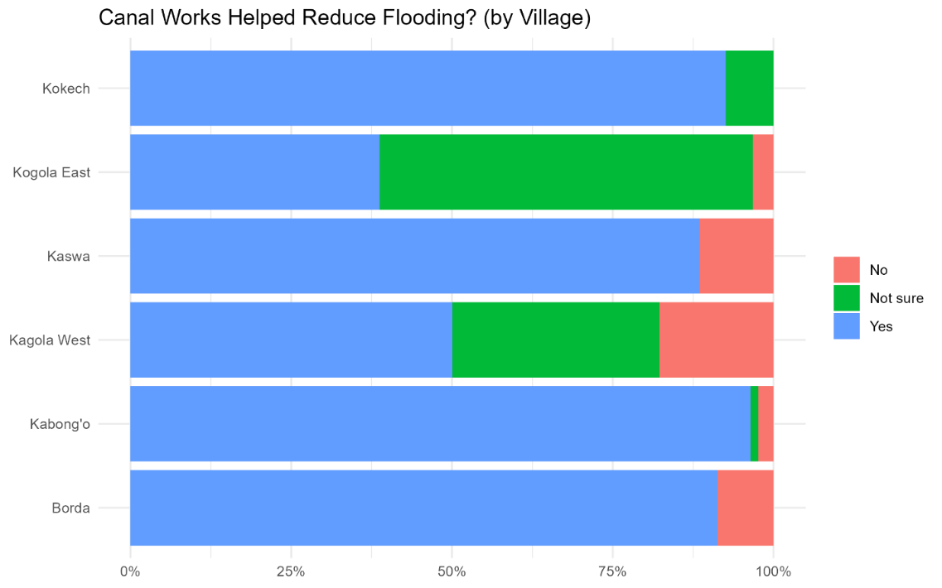
Stacked plots of flood damage vs. canal desilting per village highlighted that most households reporting decreased flood damage were also in areas where desilting was effective, showing direct linkage.

- 4.63 Has your home or farm been affected by flooding in the past year? ☐ Yes ☐ No. If Yes, what kind of damage did you experience? (Tick all that apply) ☐ Property damage ☐ Crop loss ☐ Water source contamination ☐ Latrine collapse ☐ Other: ___________
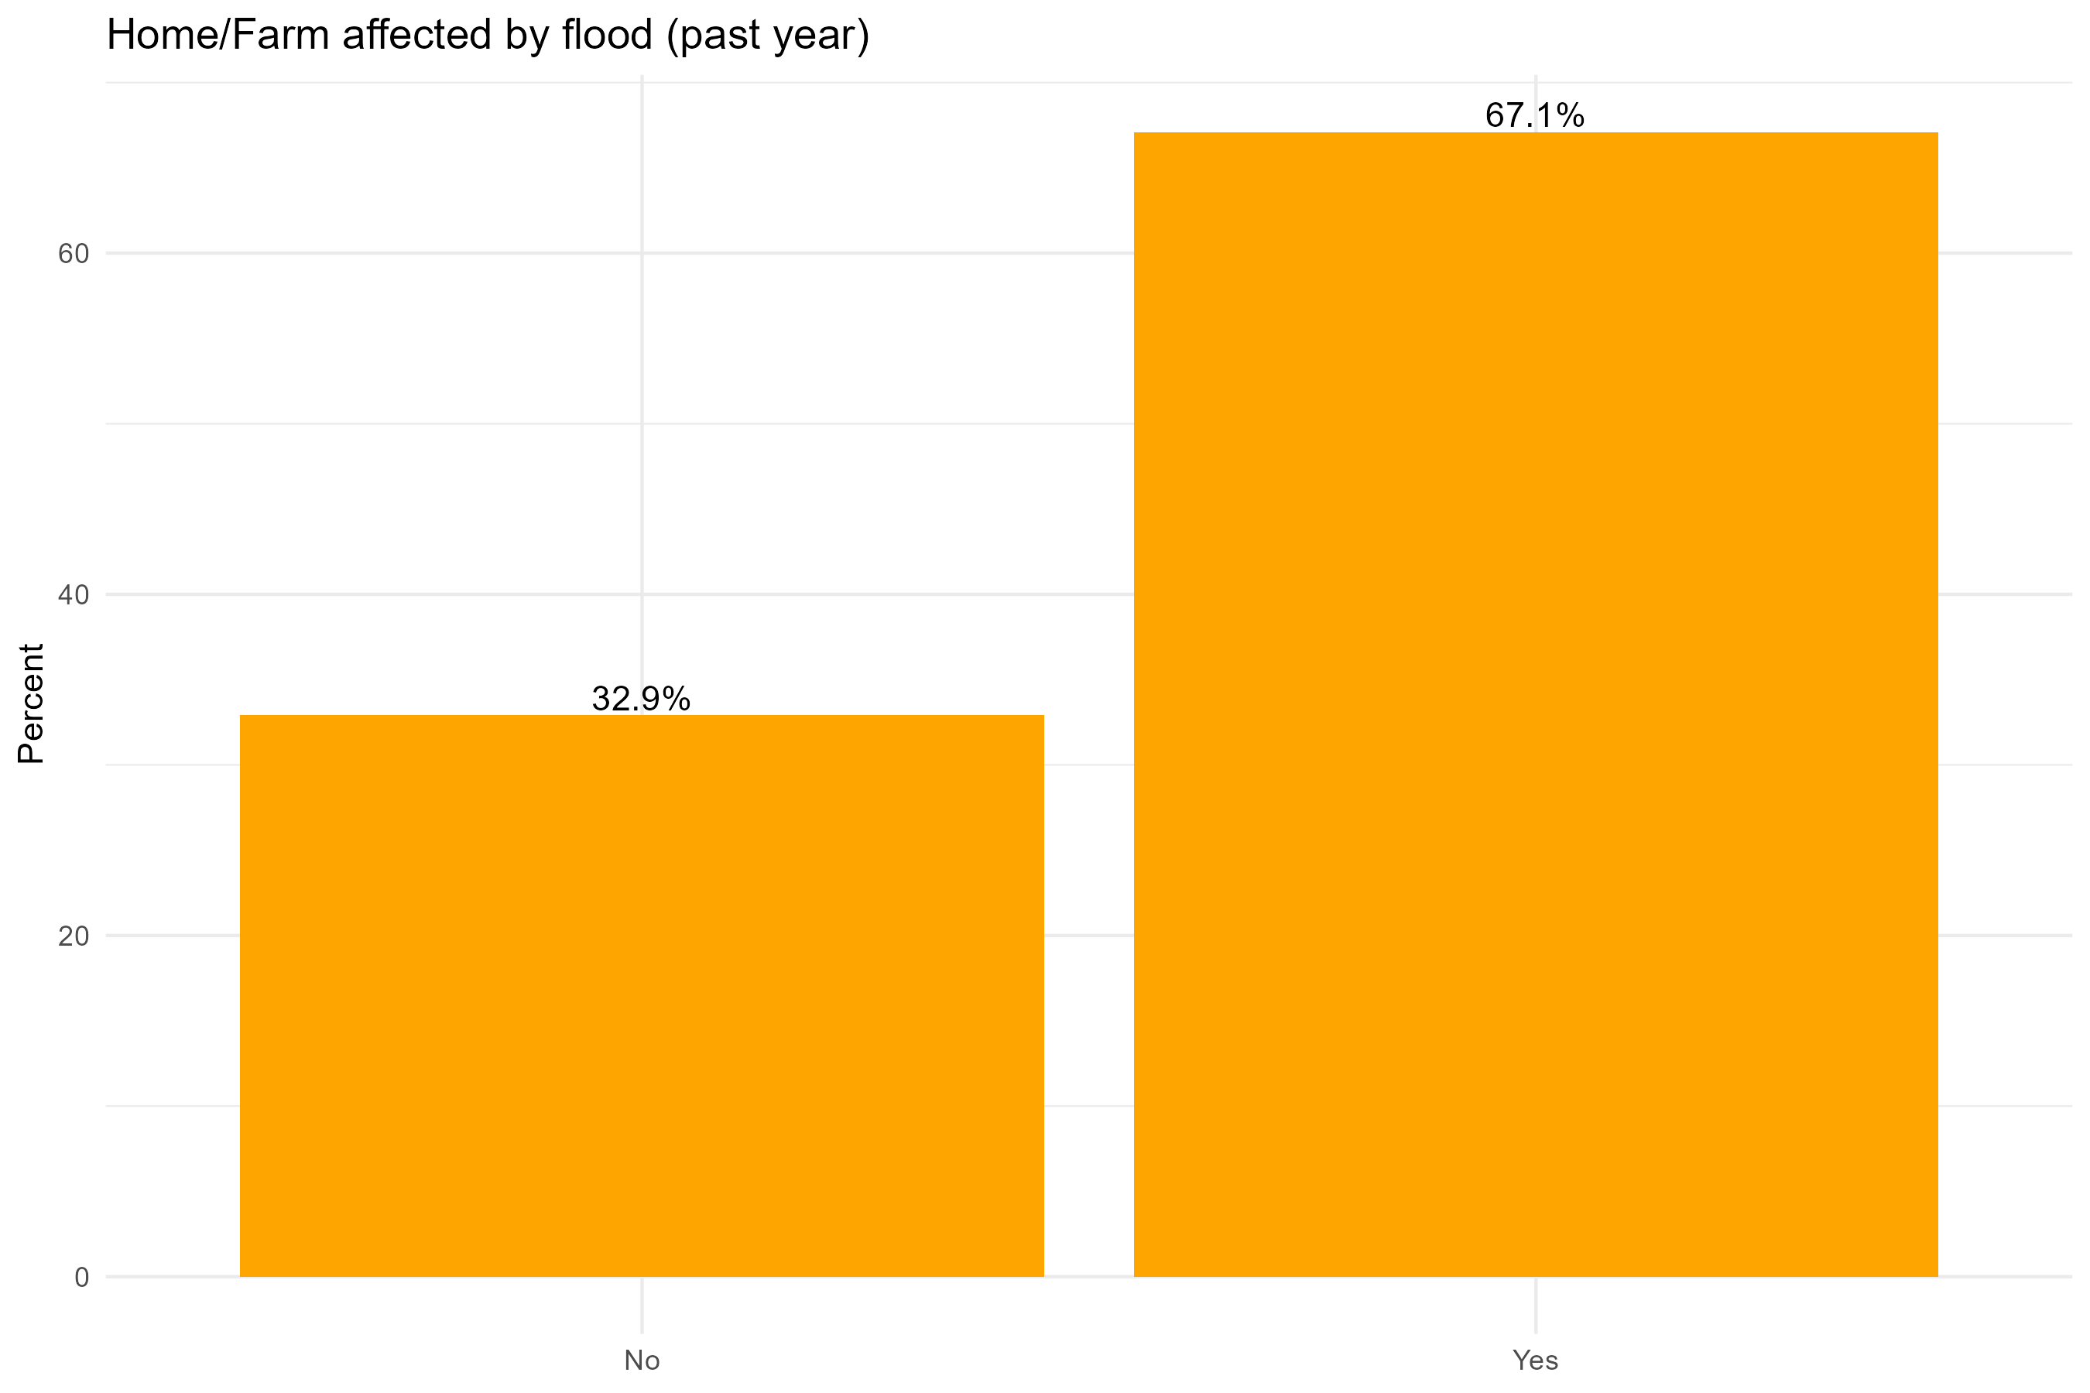

Flood Impact Frequency Table
Response | Count | Percentage
Yes - Affected by flooding | 193 | 68.90%
No - Not affected by flooding | 87 | 31.10%
Total | 280 | 100%

Damage Type Analysis (Among 193 Affected Households)
Damage Type | Count | Percentage of Affected Households
Crop Loss | 178 | 92.20%
Property Damage | 152 | 78.80%
Latrine Collapse | 127 | 65.80%
Water Source Contamination | 109 | 56.50%
Other Damage | 0 | 0%

- EFFECTIVENESS
Did the project improve access to and use of safe water?
- 4.23 Approximately how much water does your household collect per day (in litres)? ☐ <20 litres ☐ 20–50 litres ☐ 51–100 litres ☐ >100 litres (Specify exact litres if known): ________

- 4.24 How often does your household use the HFHK water kiosks? ☐ Daily ☐ 3–6 times/week ☐ 1–2 times/week ☐ Rarely ☐ Never
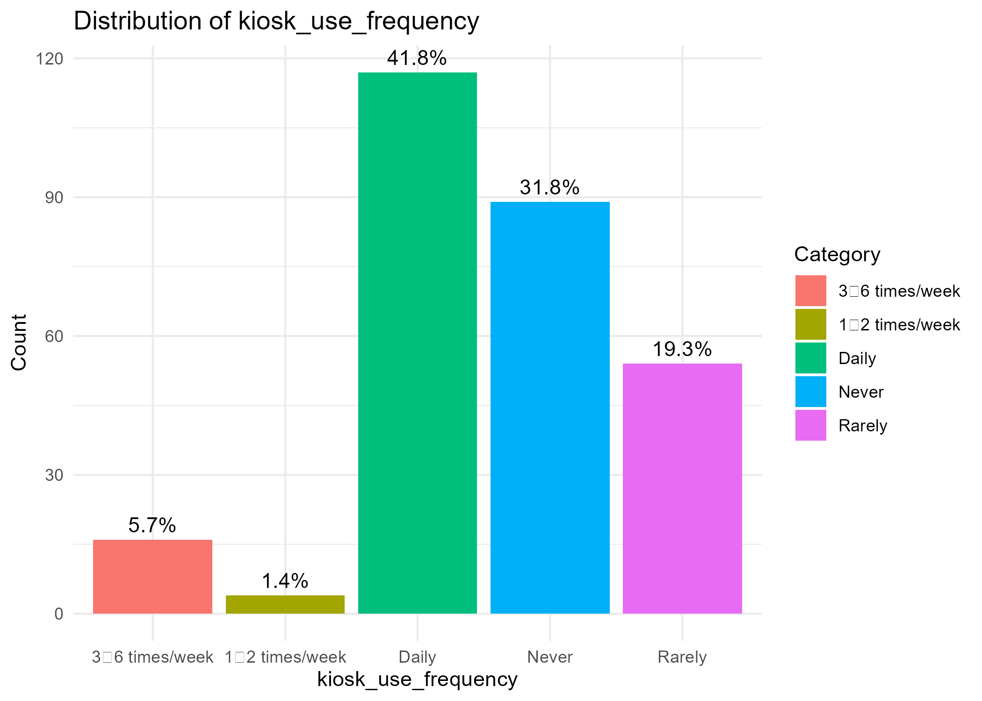

- 4.25 How much time did it take to fetch water before the project? ☐ <30 min ☐ 30–60 min ☐ >1 hour
- 4.26 How much time does it take to fetch water now? ☐ <30 min ☐ 30–60 min ☐ >1 hour

- 4.27 Compared to before the project, is this time to fetch water now: Less / Same / More?

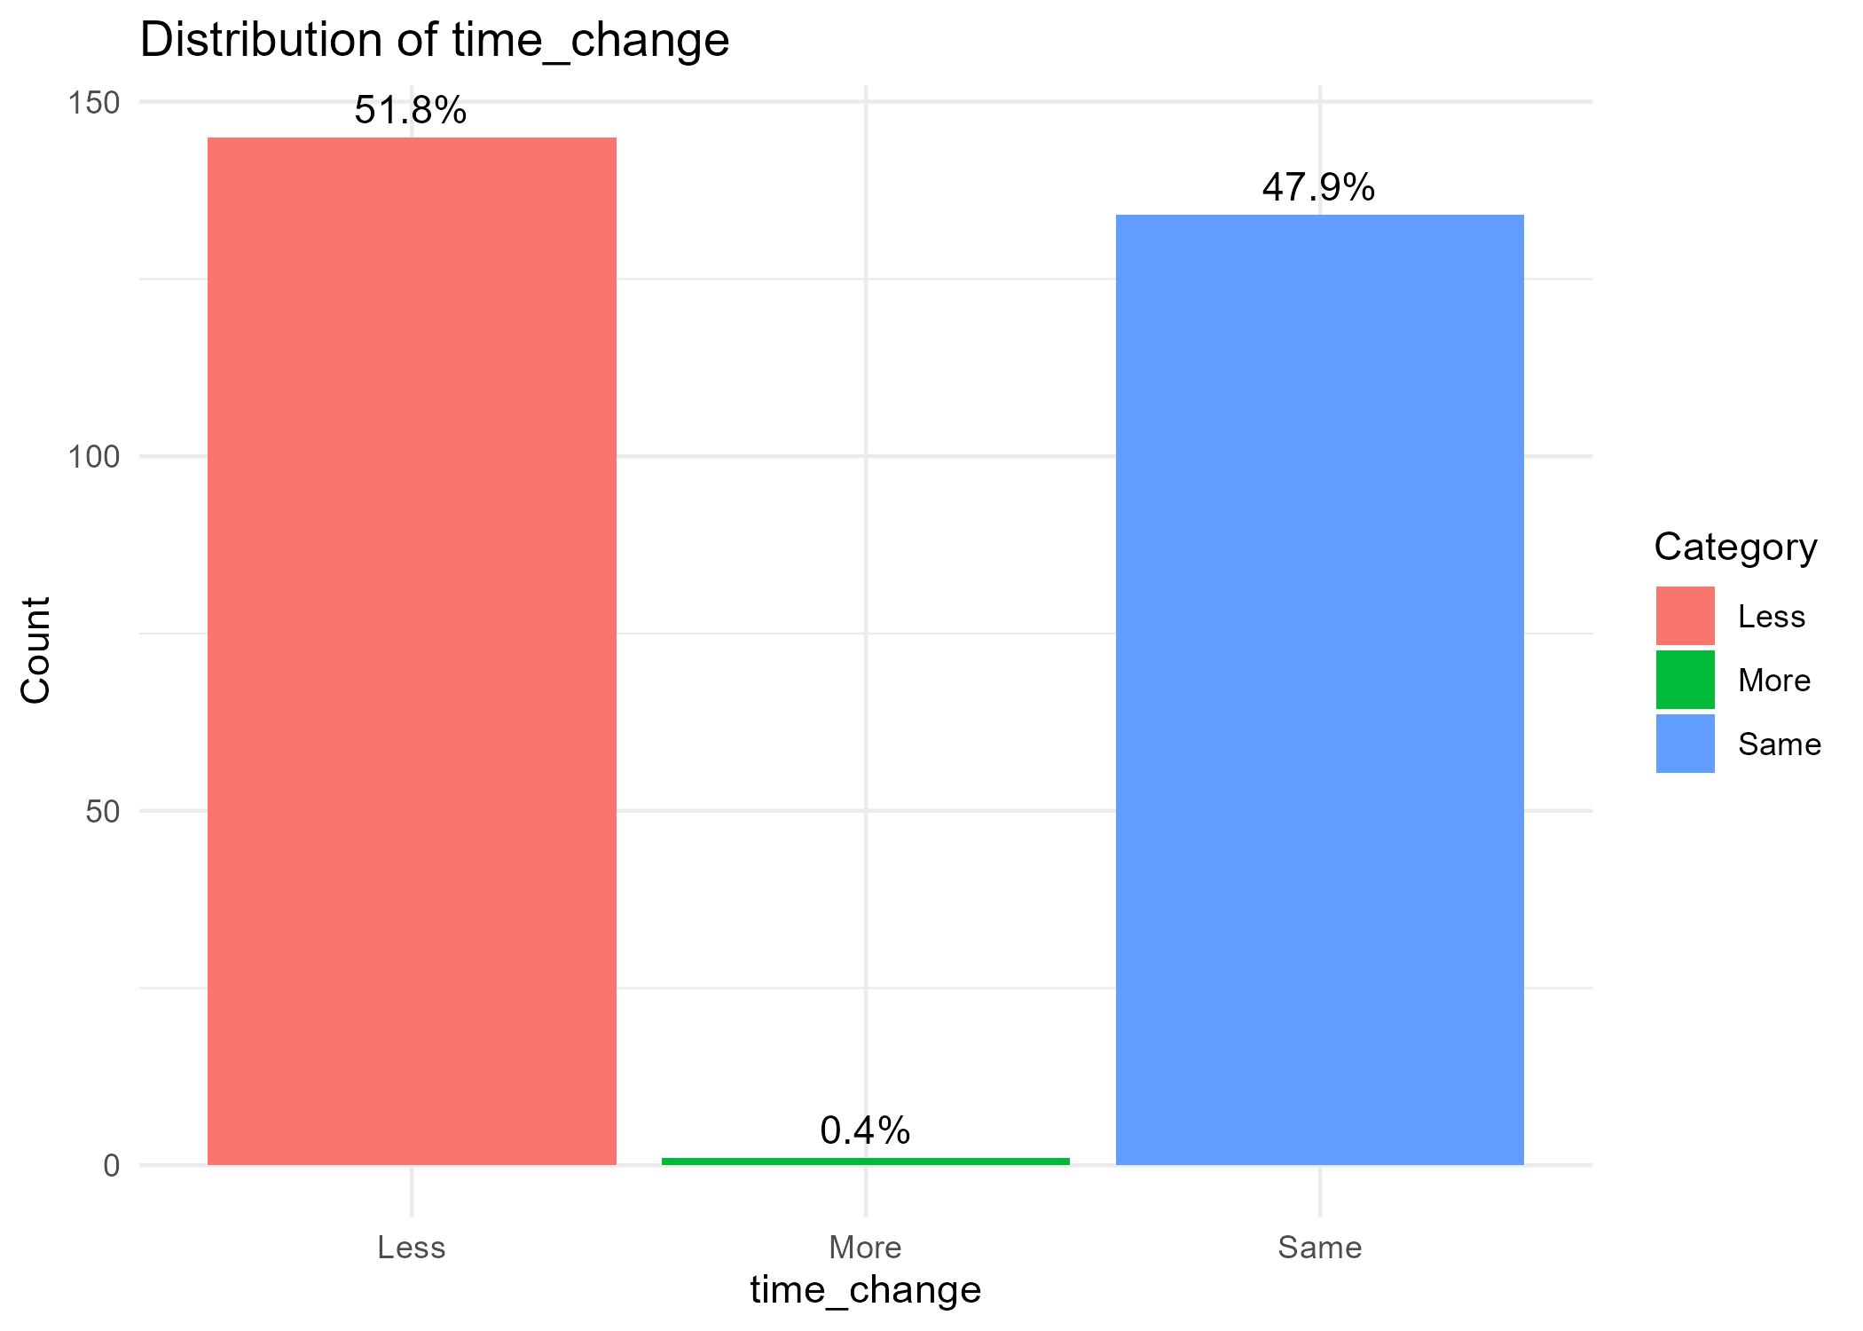
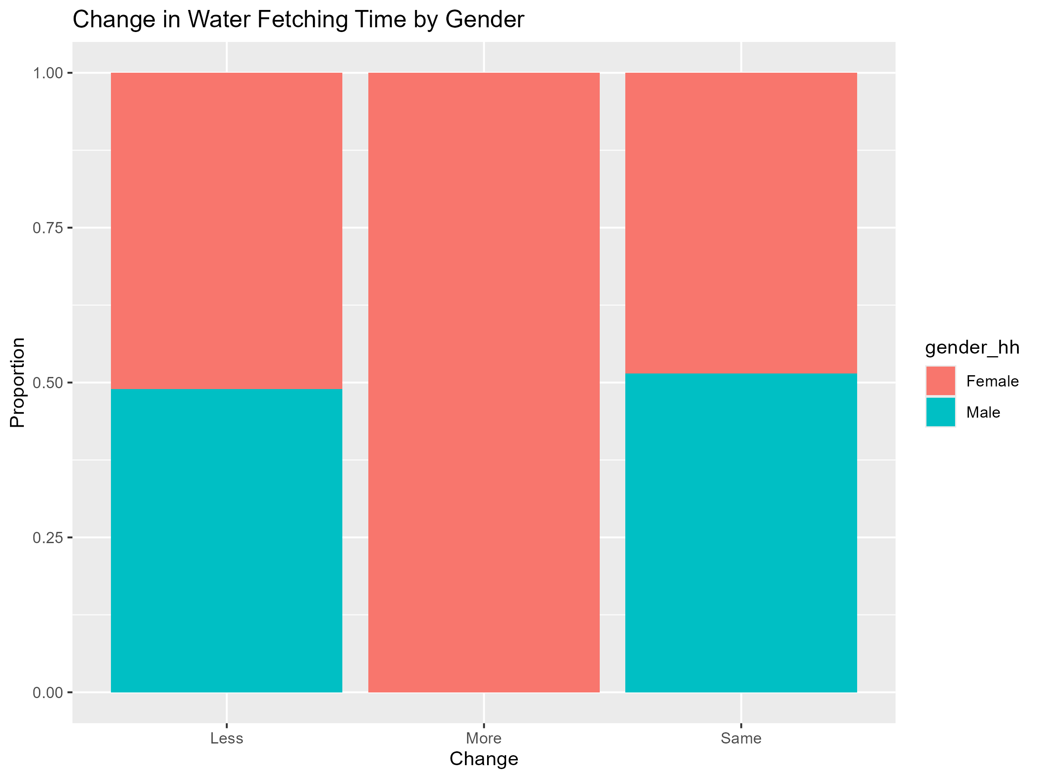
Time to fetch water has improved for both genders: Female HH heads “Less time” 52.9%; Male HH heads 50.7% (about half for each).
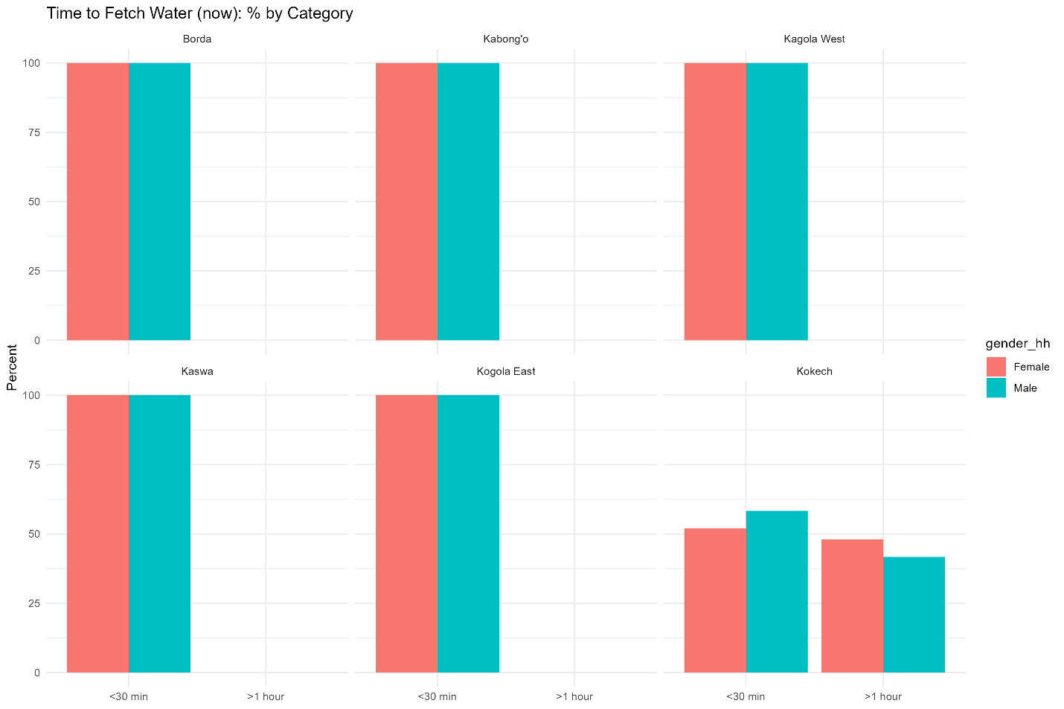

- 4.30 Compared to before the project, how would you rate the quality of your household’s drinking water? ☐ Improved (minimal salinity, clearer, fewer illnesses) ☐ No change ☐ Worse

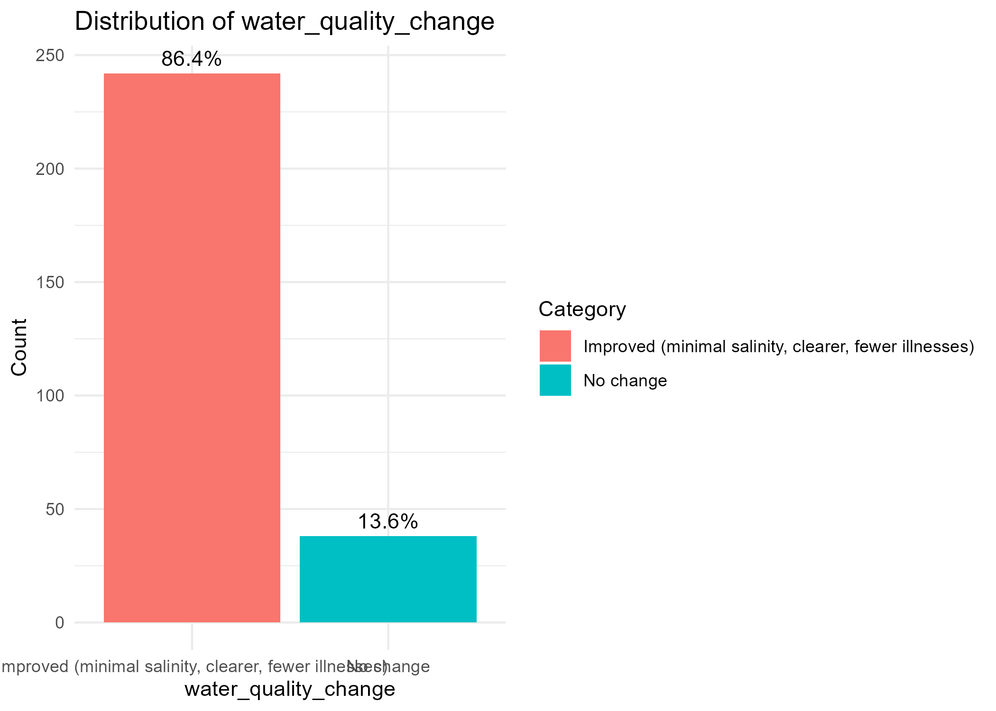

- 4.31 Is the Solar-Powered Borehole Functional? ☐ Yes ☐ No (Reason: _________________________)

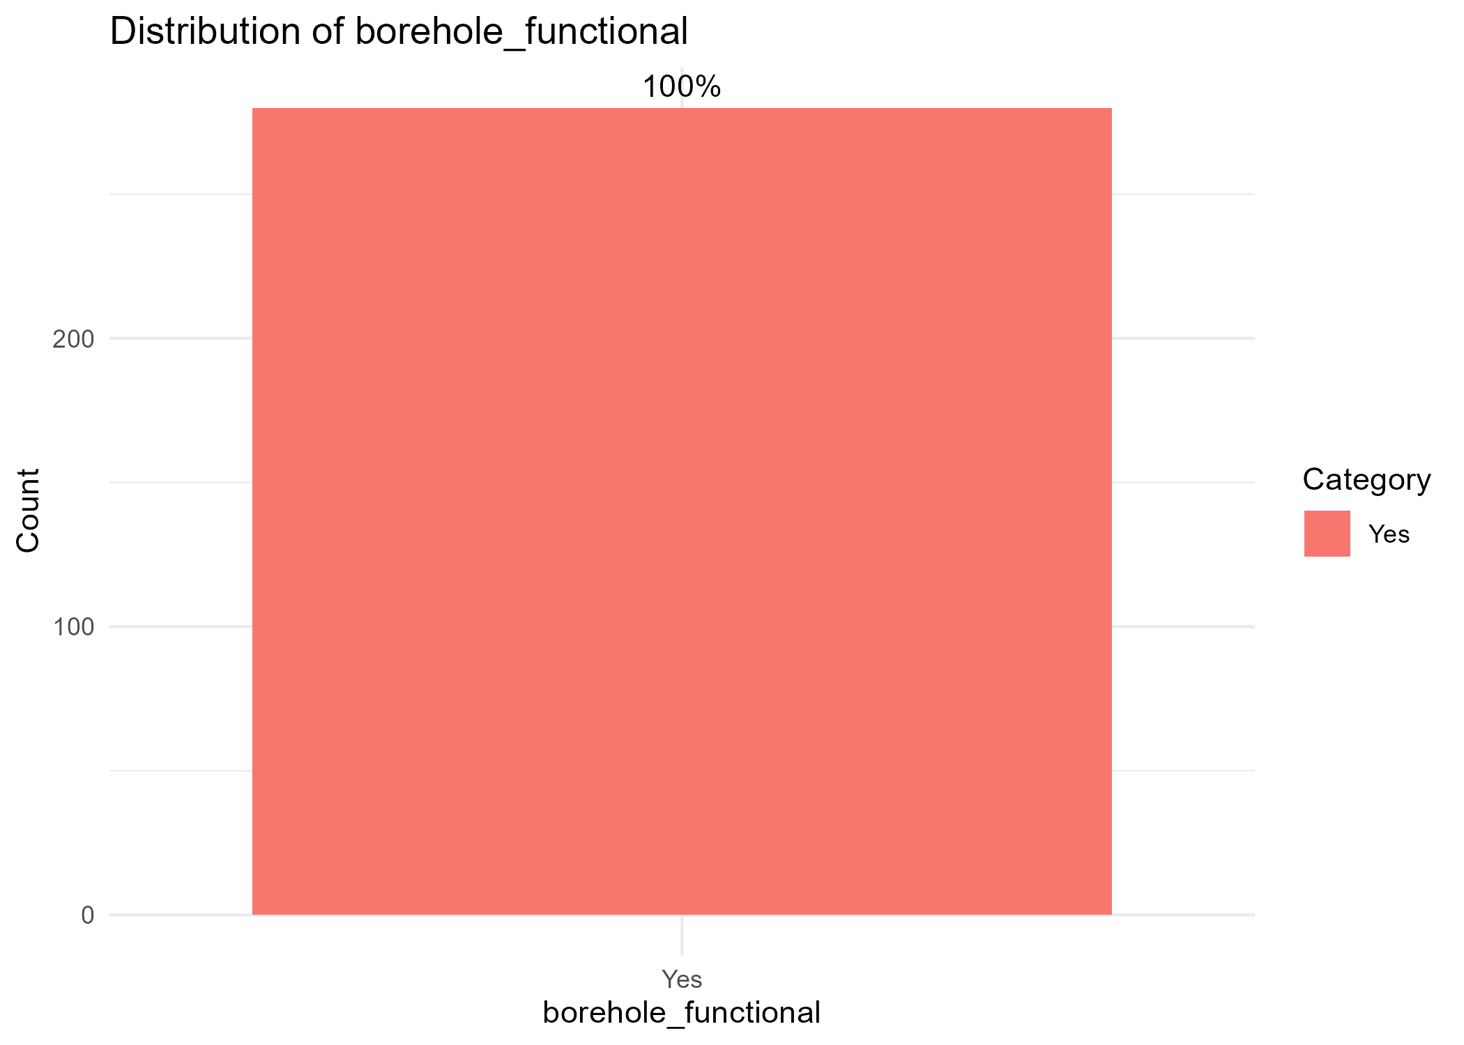
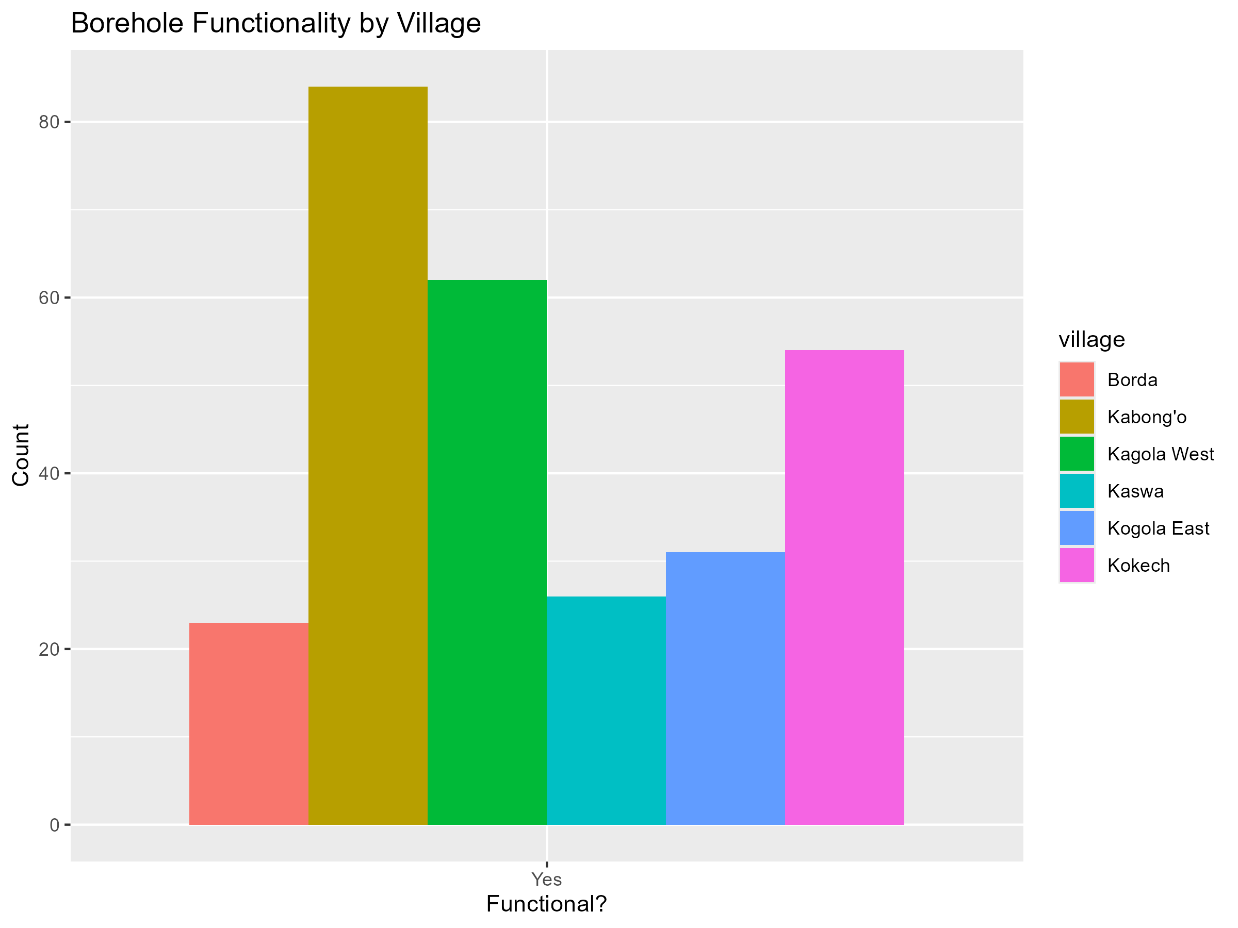
- 4.32 Do you experience water shortages or breakdowns in the system? ☐ Yes ☐ No. If yes, how often do you experience breakdowns of the water system? ☐ rarely (once every few months) ☐ frequently (monthly or more)
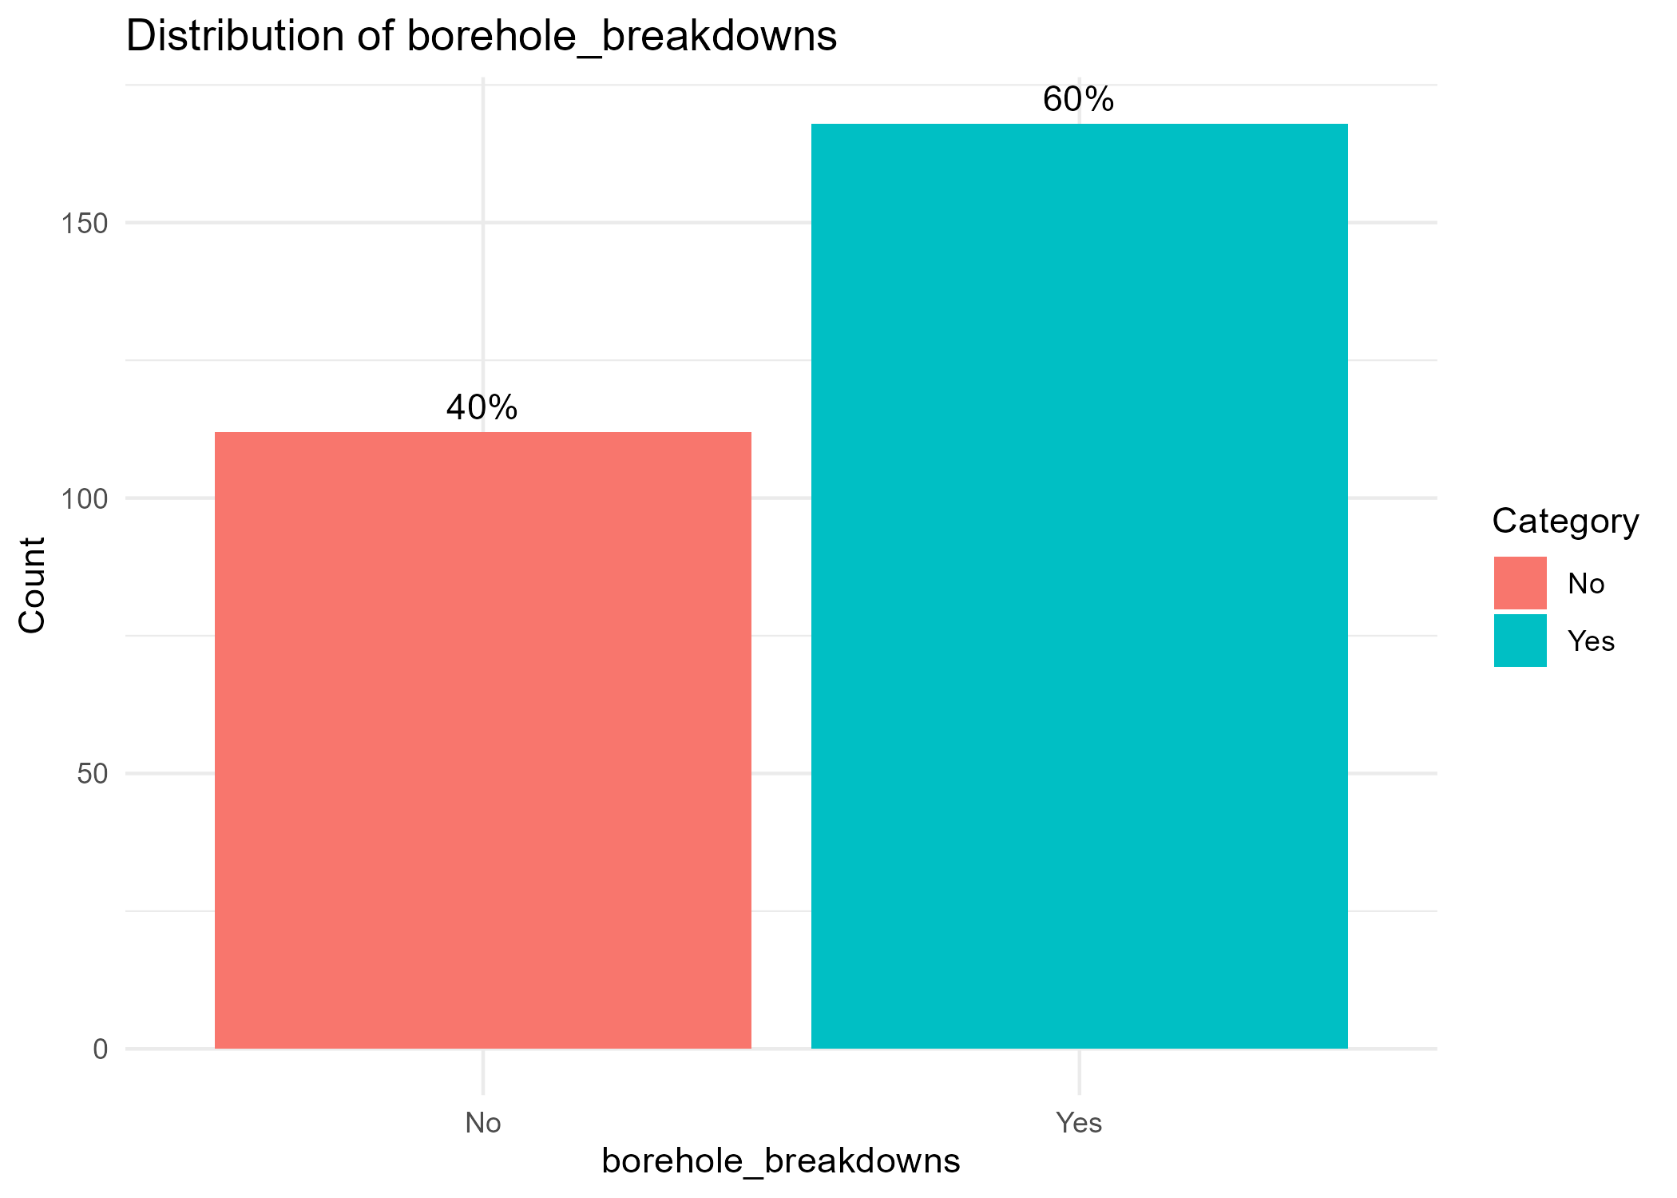
- 60% of households overall reported experiencing borehole/kiosk shortages or breakdowns in the past year.
- Among those reporting, 99% said breakdowns were rare (only once every few months), while less than 1% cited frequent breakdowns.
While breakdowns do occur, they are generally infrequent and manageable, showing a robust but not flawless system.

Did the project lead to improved sanitation & hygiene behaviors?
- 3.13 Do you have a handwashing station at home? [Yes/No]. If yes, what does it include? ☐ Soap ☐ Ash ☐ Water only ☐ Nothing

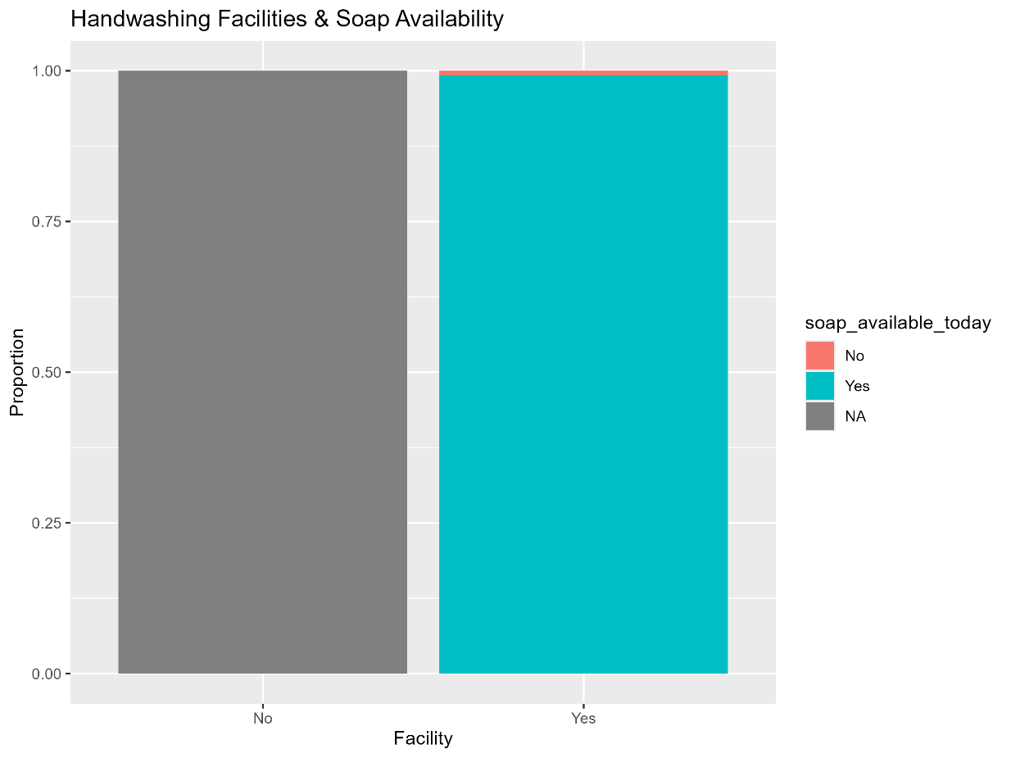
Handwashing facilities are widespread: place to wash hands Yes = 264/280; where present, soap available = 262 translating to 93.6%.

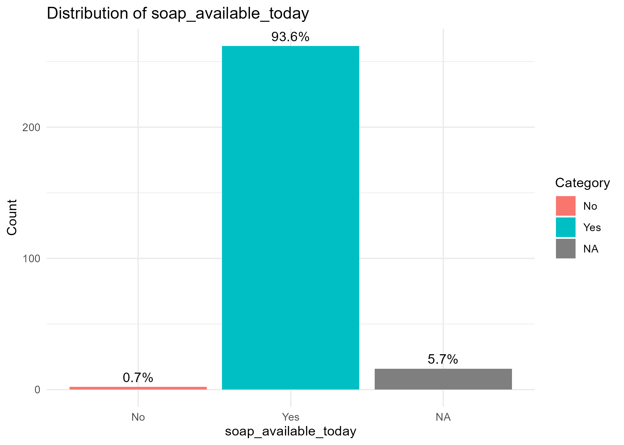

- 3.14 When do you and your family wash hands? (Select all that apply) ☐ After toilet use ☐ Before eating ☐ Before cooking ☐ After handling waste ☐ After cleaning the environment ☐ Other: _______________

Handwashing Behavior Frequency Analysis

Table 1: Overall Handwashing Occasion Awareness
Handwashing Occasion | Respondents | Percentage
After defecation | 235 | 0.839
Before eating food | 262 | 0.936
Before preparing food | 244 | 0.871
After cleaning environment | 244 | 0.871
After handling child/adult feces | 235 | 0.839

Table 2: Combination Patterns (Top 5 Most Common)
Combination Pattern | Respondents | Percentage
All 5 occasions | 186 | 0.664
4 out of 5 occasions | 42 | 0.15
3 out of 5 occasions | 28 | 0.1
2 out of 5 occasions | 16 | 0.057
1 occasion only | 8 | 0.029

Table 3: Specific Missing Components (Among Those Not Selecting All 5)
Missing Component | Respondents | Percentage of Incomplete Responses
After handling child/adult feces | 32 | 0.34
After defecation | 28 | 0.298
After cleaning environment | 18 | 0.191
Before preparing food | 16 | 0.17
Before eating food | 12 | 0.128

Table 4: Minimal Handwashing Practices
Practice Pattern | Respondents | Percentage
Before eating + Before preparing only | 12 | 0.043
After defecation only | 4 | 0.014
Before eating only | 2 | 0.007
After cleaning only | 2 | 0.007

- 3.15 In your view, have your family’s hygiene practices improved since 2021? ☐ Yes ☐ No. If yes, please describe how: _____________________________

Response | Count | Percentage
Yes | 278 | 99.00%
No | 2 | 1.00%
Total Responses | 195 | 100%

An overwhelming majority (99%) of respondents reported that their family's hygiene practices have improved since 2021.
The data presents a very strong positive outcome. The near-unanimous "Yes" response indicates a highly successful intervention. The descriptions show a clear causal chain:
Training (from CHVs/HFHK) + Improved Infrastructure (water kiosks) → Adoption of New Behaviors (handwashing, cleaning, treating water) → Direct Health Impact (reduction in disease) → Perceived Improvement in Hygiene Practices.
The reduction in waterborne diseases is not just a perceived benefit but is reported as the most tangible and valued result of the improved hygiene practices.

- 4.37 Does your household use an HFHK-constructed latrine? ☐ Yes ☐ No
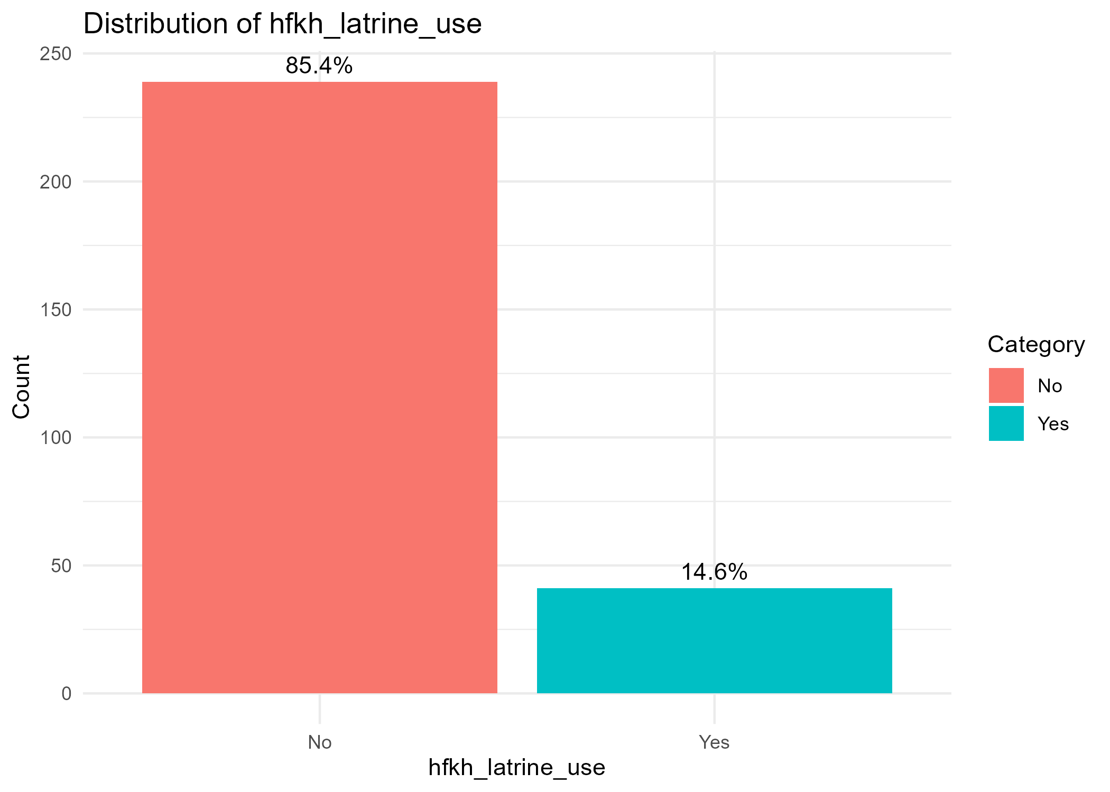
- 4.40 Does everyone in your household regularly use the latrine? ☐ Yes ☐ No ☐ Not all members

Response | Frequency | Percentage
Yes | 120 | 100%
No | 0 | 0%
Not all members | 0 | 0%
Total | 120 | 100%

- 4.41 Do girls or women in your household feel comfortable using the latrine at night? ☐ Yes ☐ No ☐ Sometimes

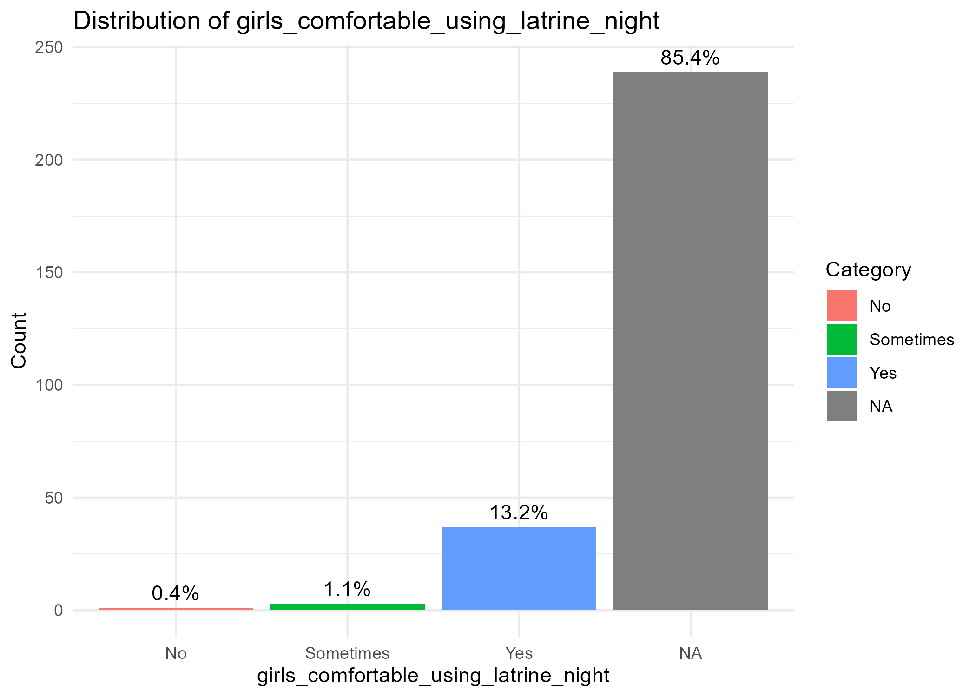

- 4.43 Is there a place in your homestead to wash hands? ☐ Yes ☐ No → Is water available? ☐ Yes ☐ No → Is soap available today? ☐ Yes ☐ No
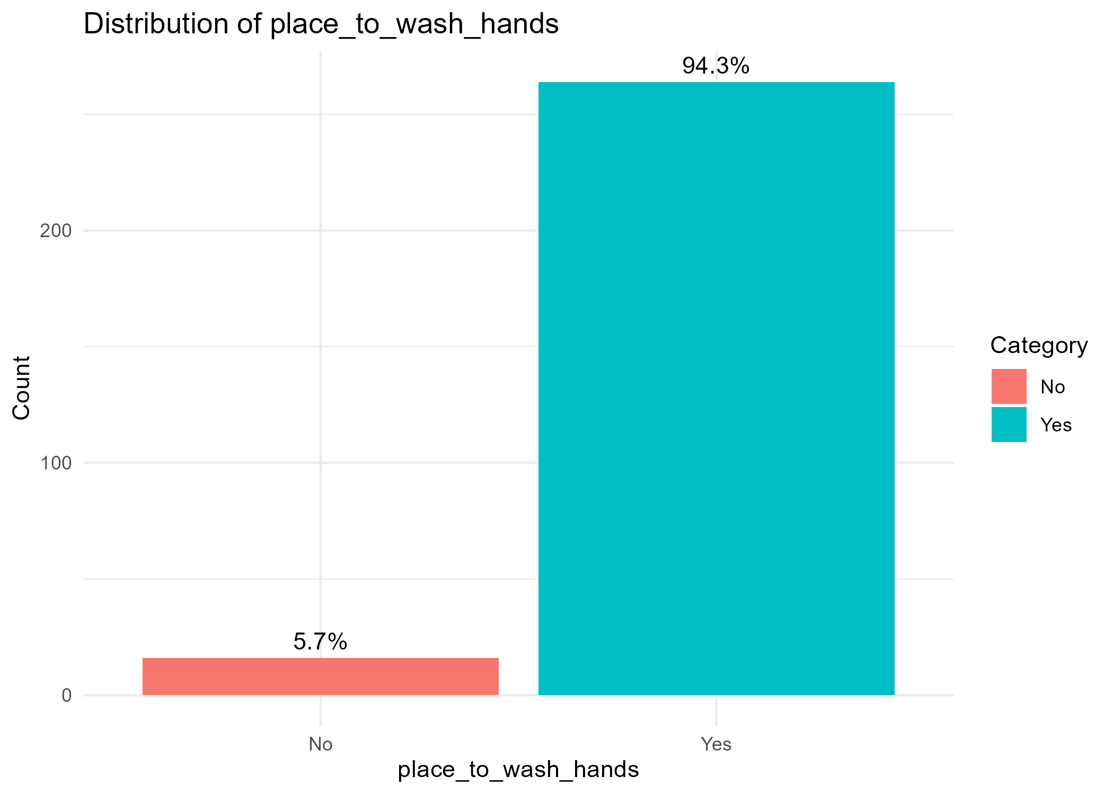

- 4.44 When should you wash hands (knowledge check) (after defecation, after handling child/adult feces or cleaning child's bottom, after cleaning the environment, before preparing food, and before eating food)

Handwashing Occasion | Respondents | Percentage
After defecation | 235 | 0.839
Before eating food | 262 | 0.936
Before preparing food | 244 | 0.871
After cleaning environment | 244 | 0.871
After handling child/adult feces | 235 | 0.839

- 4.45 How often do you wash your hands at the following times? (behavior check) (Tick one option for each situation)
  - Situation: After defecation | Often ☐ | Sometimes ☐ | Never ☐
  - Situation: Before eating | Often ☐ | Sometimes ☐ | Never ☐
  - Situation: Before preparing food | Often ☐ | Sometimes ☐ | Never ☐
  - Situation: After cleaning the environment | Often ☐ | Sometimes ☐ | Never ☐
  - Situation: After handling child/adult feces | Often ☐ | Sometimes ☐ | Never ☐

Handwashing Frequency Analysis

Table 1: Overall Frequency Distribution by Situation
Situation | Often | Sometimes | Never | Total Responses
After defecation | 255 (91.1%) | 25 (8.9%) | 0 (0%) | 280
Before eating | 280 (100%) | 0 (0%) | 0 (0%) | 280
Before preparing food | 238 (85.0%) | 42 (15.0%) | 0 (0%) | 280
After cleaning environment | 256 (91.4%) | 23 (8.2%) | 1 (0.4%) | 280
After handling child/adult feces | 274 (97.9%) | 6 (2.1%) | 0 (0%) | 280

Table 2: Consistency Across All Five Situations
Consistency Pattern | Respondents | Percentage
"Often" for all 5 situations | 225 | 80.40%
4 "Often" + 1 "Sometimes" | 42 | 15.00%
3 "Often" + 2 "Sometimes" | 11 | 3.90%
Other combinations | 2 | 0.70%

Table 3: Most Common Inconsistent Patterns
Pattern | Respondents | Percentage
Before preparing food = Sometimes | 38 | 13.60%
After defecation = Sometimes | 22 | 7.90%
After cleaning environment = Sometimes | 20 | 7.10%

Table 4: Perfect Handwashing Compliance
Metric | Value
100% "Often" across all situations | 225 respondents
Percentage of total | 80.40%

- 4.47 Which of the following hygiene or sanitation practices have you started or improved in your household as a result of the PHAST/CHAST training or home visits? (Tick all that apply) ☐ Wash hands with soap after defecation ☐ Wash hands with soap before eating or preparing food ☐ Built or improved household latrine ☐ Treat drinking water (e.g., boiling, chlorination) ☐ Store water safely in clean, covered containers ☐ Use a squat hole cover or toilet seat ☐ Keep latrine and surrounding area clean ☐ Constructed or use a handwashing station (e.g., tippy tap) ☐ Practice safe disposal of child feces ☐ Other (please specify): _______________________

Practice | Count | Percentage of Total Respondents (N=280)
Wash hands with soap after defecation | 278 | 0.993
Wash hands with soap before eating or preparing food | 277 | 0.989
Treat drinking water (e.g., boiling, chlorination) | 251 | 0.896
Store water safely in clean, covered containers | 238 | 0.85
Keep latrine and surrounding area clean | 203 | 0.725
Constructed or use a handwashing station | 194 | 0.693
Practice safe disposal of child feces | 192 | 0.686
Built or improved household latrine | 159 | 0.568
Use a squat hole cover or toilet seat | 120 | 0.429
Other (please specify) | 1 | 0.004

Key Findings and Implications
- Overwhelming Success in Key Behaviors - The intervention was remarkably successful in promoting the two most critical hygiene behaviors: handwashing after defecation and before handling food. The near-100% adoption rate is an excellent outcome.
- Holistic Impact - The adoption rates show a comprehensive impact, covering the main pillars of WASH: Water (treatment, storage), Sanitation (latrine construction/improvement, cleaning, covers), and Hygiene (handwashing stations, handwashing behavior, safe feces disposal).
- Behavior Change vs. Infrastructure - The data shows a mix of pure behavior change (e.g., handwashing, water treatment) and infrastructure-related improvements (e.g., building latrines, constructing handwashing stations). This suggests the program likely provided both knowledge and some level of material support or motivation for household investment.
- Potential for Further Improvement - While latrine construction and use of squat hole covers have good adoption rates, they are the areas with the most potential for further growth. Future programs could focus more on promoting these specific hardware-related improvements.
- Correlation with Health Outcomes - The high adoption rates for these practices directly explains the reduction in waterborne diseases (like cholera, typhoid, and diarrhea) reported in the responses to question 3.15. This creates a clear logical chain from Training -> Adoption of Practices -> Improved Health Outcomes.
In sum, the PHAST/CHAST training and home visits were highly effective across the board. The data reveals a community that has not only learned new information but has acted upon it decisively. Households have made significant improvements, ranging from simple behavioral changes to substantial investments in household infrastructure. This widespread adoption of improved WASH practices provides a strong foundation for sustained better health and well-being in the community.

- 4.48 In your view, has the PHAST/CHAST hygiene training contributed to a reduction in illness (such as diarrhea or stomach problems) in your household? ☐ Yes ☐ No ☐ Not sure. If Yes, what changes have you observed? If No, why do you think the training has not had an impact?

Overall Response Distribution
Response | Count | Percentage of Total Respondents
Yes | 199 | 0.836
No | 5 | 0.021
Not sure | 34 | 0.143
Total Analyzed | 238 | 1

Detailed Analysis of Responses

A. "Yes" Responses (199 respondents, 83.6%)
Respondents who answered "Yes" described the specific changes they observed. These responses can be categorized into several key themes:
Thematic Analysis of Observed Changes:
Theme | Example Quotes from Respondents | Implied Impact
1. Reduction in Disease Incidence | "Reduction of water borne disease", "Zero cholera cases", "Reduced cases of diarheal diseases", "No water borne diseases", "Fewer illness" | Direct Health Outcome: This is the most direct and frequently cited evidence of impact.
2. Reduced Hospital Visits & Cost Savings | "Less Movement to the hospital", "Rarely visit the hospital", "Less money to treat diseases", "Reduced medical expenses", "Money used for treatment can now help to buy food" | Economic & Access Impact: Highlights the financial and logistical burden lifted from households due to better health.
3. Improved Hygiene Knowledge & Behavior | "We know time to wash our hands", "Through hand washing, there's less spread of germs", "I have installed hand washing containers", "Improved skills on feces disposal" | Behavioral Change: Shows a clear link between the training, adopted practices, and the resulting health benefits.
4. Specific Disease Reduction | "Reduction of cholera cases", "There are no cases of Typhoid", "Reduced cases of waterborne diseases like typhoid and cholera", "Reduced oral fecal route sickness" | Targeted Health Outcome: Respondents specifically named the diseases that have declined, showing a precise understanding of the health threats addressed by WASH.
5. General Health & Well-being | "Good health", "People are healthy", "Healthy living", "Improved standards of cleanliness"

- 4.50 Has anyone in your household experienced diarrhea in the past 2 weeks?
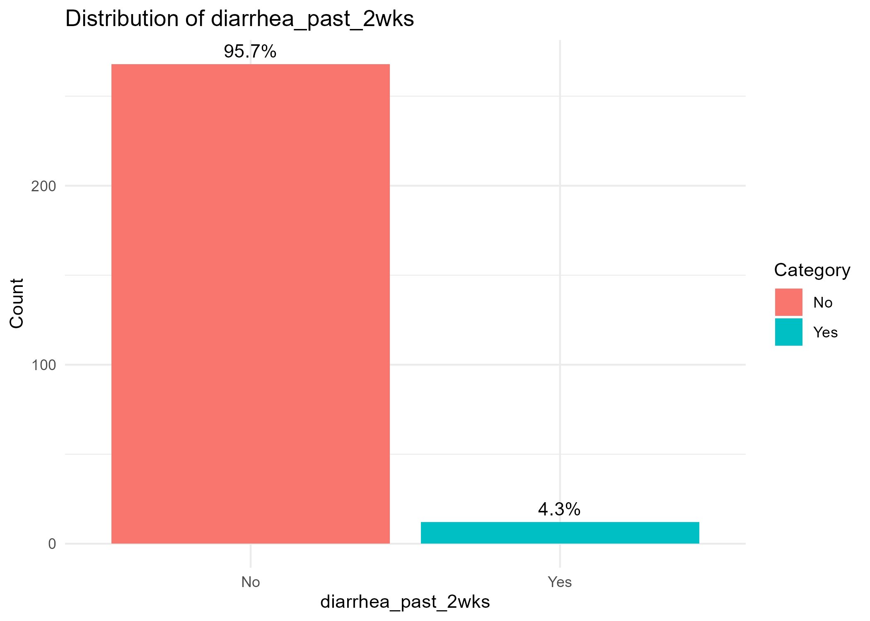
Did the project improve climate resilience and preparedness?
- 4.52 Which of the following flood preparedness actions has your household taken? (Tick all that apply) ☐ Stored food/water in advance ☐ Raised household belongings ☐ Built/raised latrine above ground ☐ Dug or cleared drainage/canals ☐ Developed evacuation plan ☐ Planted trees along canals ☐ Other: ___________ ☐ None

Overall Summary Table
Preparedness Action | Count | Percentage of Households (N=280)
Stored food/water in advance | 262 | 0.936
Raised household belongings | 186 | 0.664
Dug or cleared drainage/canals | 152 | 0.543
Planted trees along canals | 144 | 0.514
Built/raised latrine above ground | 87 | 0.311
Developed evacuation plan | 67 | 0.239
None | 2 | 0.007
Other (Specify) | 0 | 0

- 4.53 Are you aware of the canal desilting work done during the project? ☐ Yes ☐ No
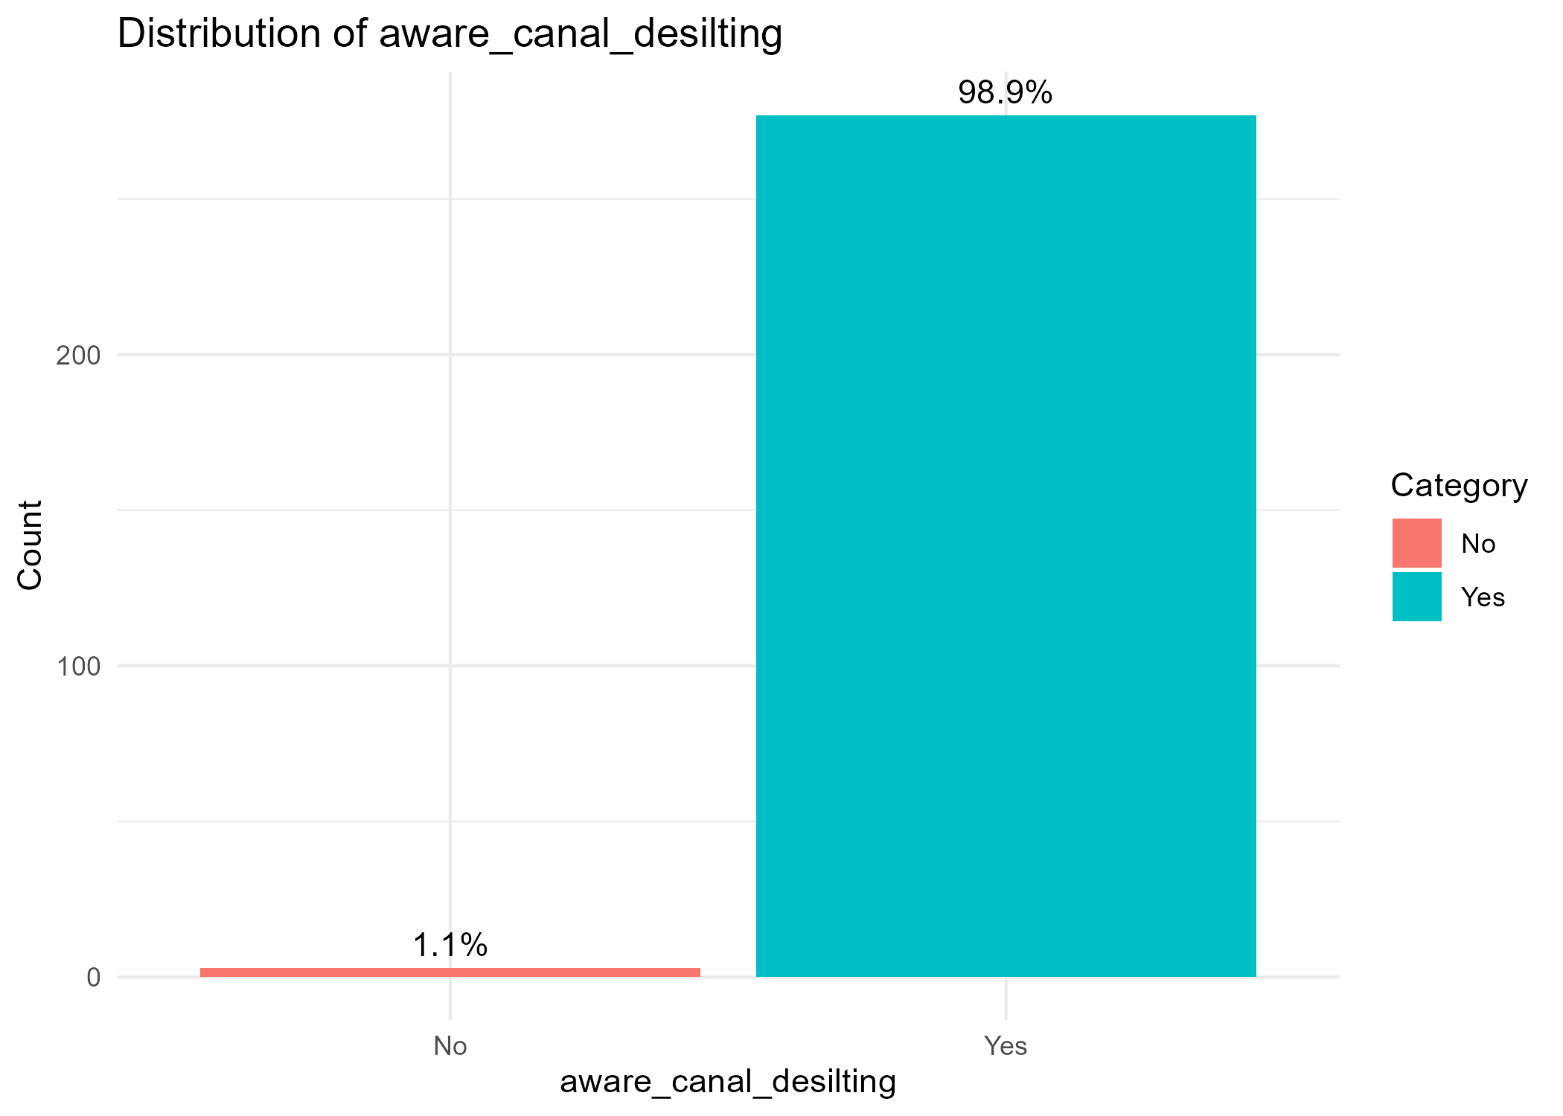
- 4.54 Did anyone in your household participate in flood risk awareness sessions organized by the project? ☐ Yes ☐ No
Response | Count | Percentage
Yes | 146 | 0.521
No | 134 | 0.479
Total | 280 | 1
The project successfully engaged a core group of the community, with a slight majority of households participating in the flood risk awareness sessions. However, to build comprehensive community resilience, future initiatives should focus on strategies to increase participation and ensure the crucial information on flood risk reaches a larger audience, ideally closer to 100% of households in vulnerable areas.

- 4.55 How useful were the flood awareness sessions for your household? ☐ Very useful ☐ Somewhat useful ☐ Not useful ☐ Did not attend

Overall Response Distribution

Response | Count | Percentage
Very useful | 202 | 0.721
Somewhat useful | 70 | 0.25
Did not attend | 8 | 0.029
Not useful | 0 | 0
Total | 280 | 1

In summary, the flood awareness sessions were not only well-attended but were also perceived as highly valuable by the vast majority of participants, making them a key successful component of the project's climate resilience strategy.

- 4.56 Have the canal works helped reduce flooding in your area? ☐ Yes, significantly ☐ Somewhat ☐ No change ☐ Not sure
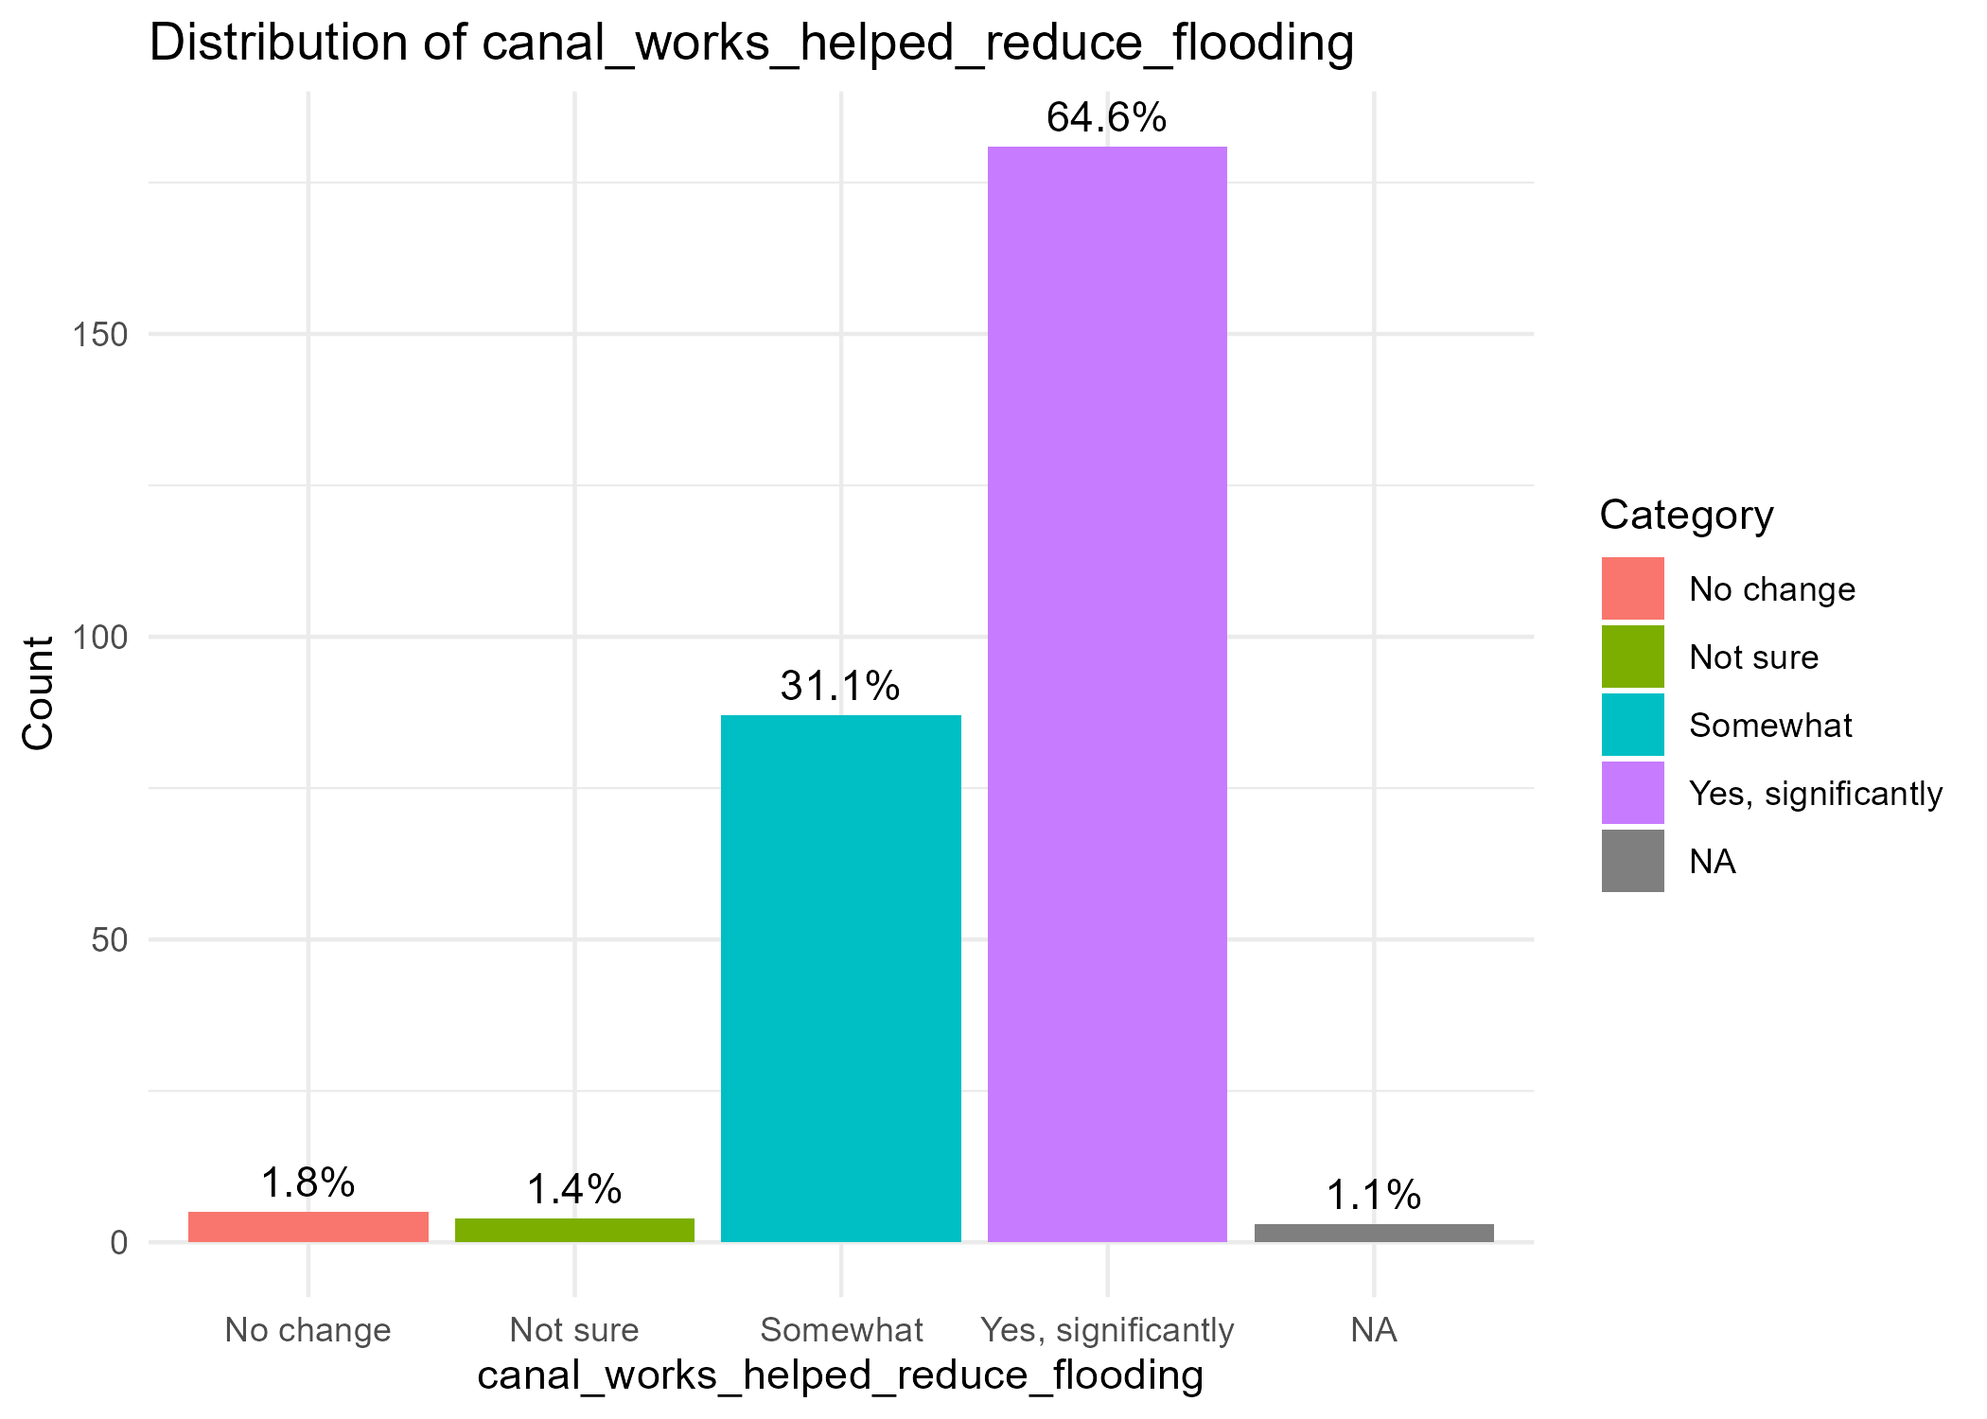

- 4.59 In your opinion, have the desilted canals and embankments reduced flooding in your area? ☐ Yes, significantly ☐ Somewhat ☐ No ☐ Not sure

- 4.60 How effective have the desilted canals and embankments been in reducing flooding in your area? o Very Effective o Somewhat effective o No change

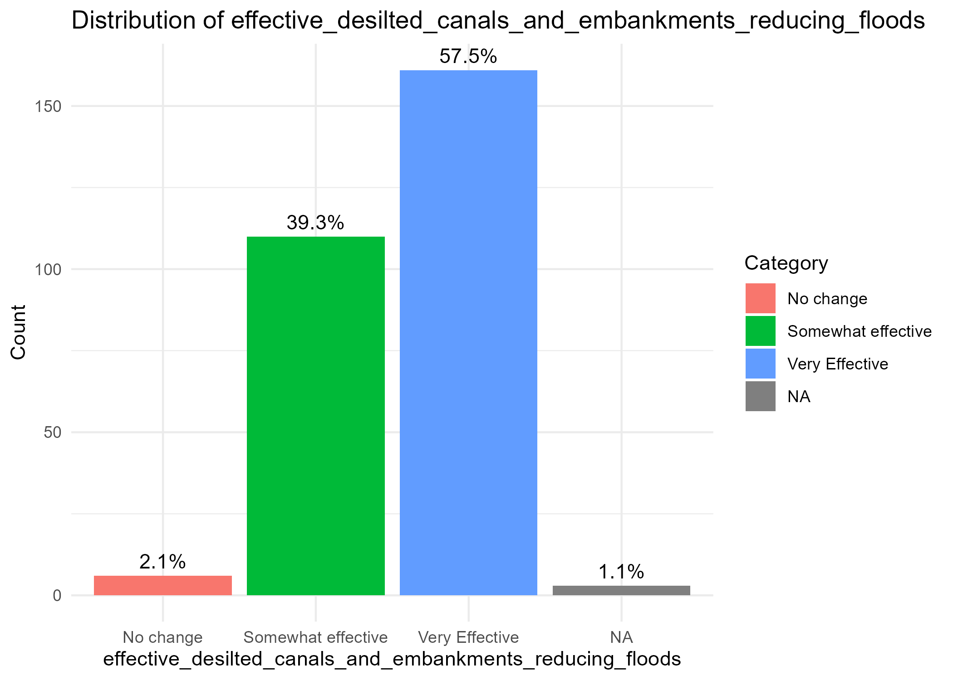

- 4.61 Do you feel your household is better prepared for seasonal flooding now compared to before the project? ☐ Yes ☐ No ☐ No change

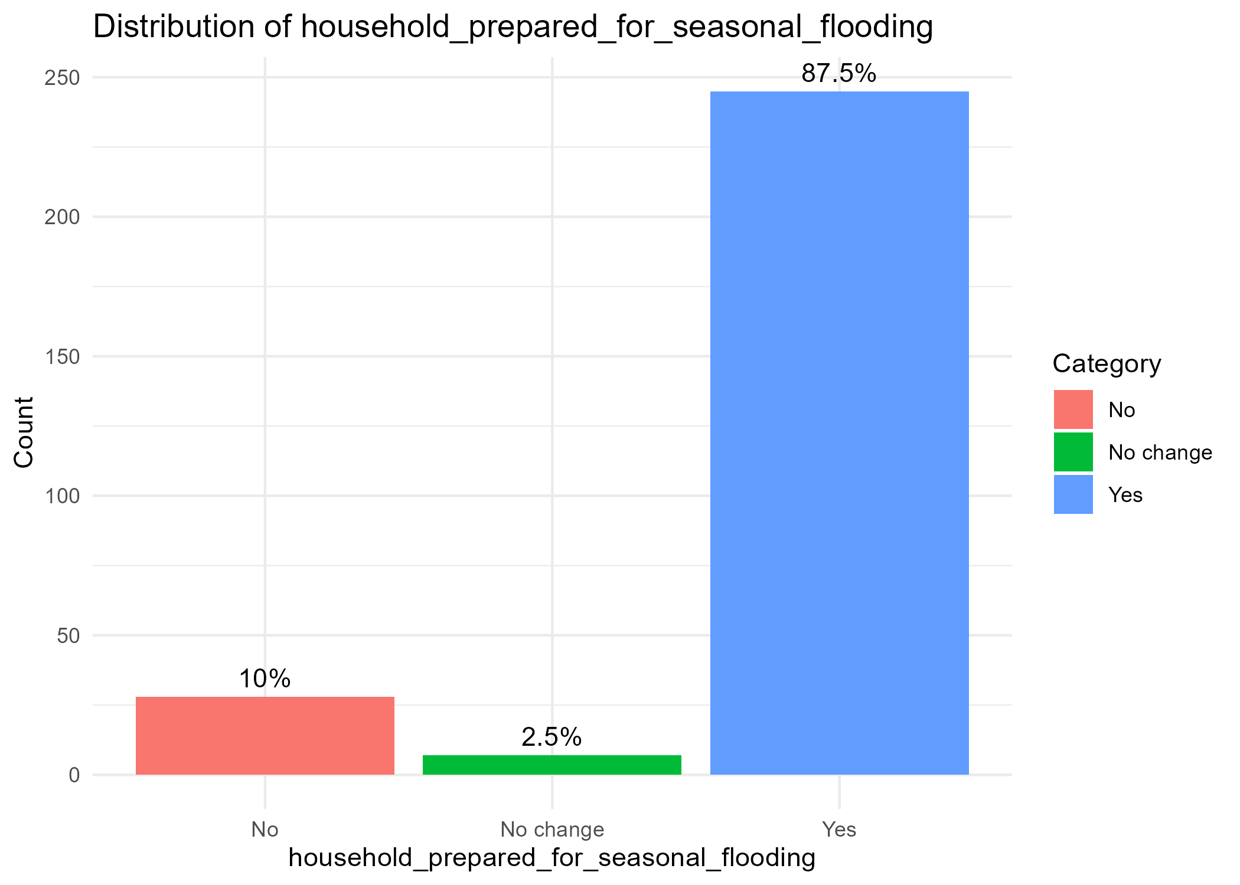

- 4.64 What should you do before a flood to protect your family and property? (Open-ended)

Thematic Analysis of Responses
Theme / Action | Count | Percentage of Respondents (N=280)
Dig/Clear/Desilt Canals & Drainage | 143 | 0.511
Raise Belongings/Property | 114 | 0.407
Store Food & Water | 85 | 0.304
Evacuate Family & Valuables | 37 | 0.132
Seek/Monitor Early Warnings | 9 | 0.032
Plant Trees/Build Gabions | 8 | 0.029
Raise/Build Latrines | 7 | 0.025
No Answer / Unclear | 21 | 0.075

- 4.65 Have you received flood early warning alerts from the canal committees or other sources? ☐ Yes ☐ No ☐ Not sure. If Yes, from whom? (Tick all that apply) ☐ Canal Committee ☐ Village Head ☐ Government official ☐ SMS/radio ☐ Other: ___________

Overall Reception of Warnings
Response | Count | Percentage
Yes | 234 | 0.836
No | 21 | 0.075
Not sure | 25 | 0.089
Total | 280 | 1

Warning Source | Count | Percentage of 'Yes' Respondents
SMS/Radio | 185 | 0.791
Government official | 142 | 0.607
Canal Committee | 127 | 0.543
Village Head | 104 | 0.444
Other | 1 | 0.004

- 4.66 Do you feel your village as a whole is better protected from flooding now compared to before the project? ☐ Much better protected ☐ Somewhat better protected ☐ No change ☐ Worse ☐ Don’t know
Response | Count | Percentage
Much better protected | 137 | 0.489
Somewhat better protected | 128 | 0.457
No change | 3 | 0.011
Don’t know | 12 | 0.043
Worse | 0 | 0
Total | 280 | 1

Were the management structures (committees) established effective?
- 4.33 Are the Water, Latrine, or Canal Committees in your area still meeting regularly? ☐ Yes ☐ No ☐ Don’t know
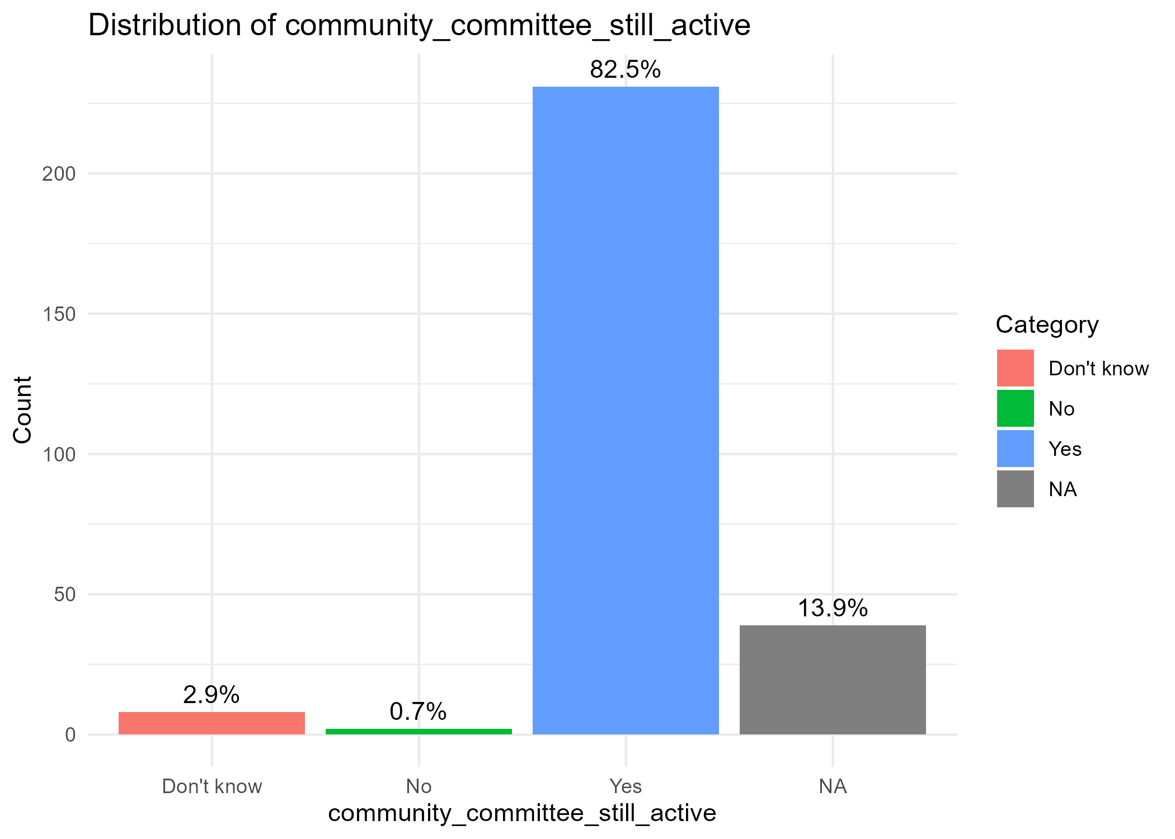
- 4.34 Who is currently responsible for repairs and maintenance of
: Water systems: ______________________ Latrines: ______________________ Canals: ______________________
- Water systems - A Community Water Committee or designated kiosk operators. This is evidenced by the organized collection of user fees at HFHK water points.
- Latrines - Individual households or groups of households that share the facility. There is no evidence of a community-wide maintenance system for latrines.
- Canals - Community Canal Committee (or a sub-group of the water committee) that was established for the desilting project. Their ongoing activity is less clear but implied as necessary.

- 4.35 Are user fees for water or sanitation services being collected and used effectively in your community? ☐ Yes ☐ No ☐ Don’t know ☐ Not applicable

Yes (for water services), from the analysis, user fees for water from HFHK kiosks are being collected consistently and are considered affordable, indicating effective daily operation. There is no mention of user fees for sanitation services.

- 4.36 In your opinion, can the community manage and sustain these services without external support? ☐ Yes ☐ No ☐ Not sure ☐ Only with partial support

Only with partial support. The community has demonstrated the ability to manage daily operations and collection of small fees. However, the low income levels and the technical nature of maintaining solar-powered water systems suggest that major repairs or large-scale canal maintenance would require financial or technical assistance from an external partner.

- 4.57 Is there a community committee that maintains the canals in your area? ☐ Yes ☐ No ☐ Not sure. If yes, is the committee still active? ☐ Yes ☐ No ☐ Don’t know

- 4.58 Have you or any household member participated in canal maintenance? ☐ Yes ☐ No
Response | Count | Percentage
Yes | 172 | 0.614
No | 108 | 0.386
Total | 280 | 1
The project successfully engaged a strong majority of the community in the hands-on, essential work of canal maintenance. This high level of participation is a key indicator of the project's success in fostering community ownership and collective action, which are crucial for the sustainability of flood control measures long after the project ends. The fact that well over half of all households contributed labor signifies a shared responsibility for managing flood risk.

- EFFICIENCY
Were project resources (time, funds, materials) used wisely from the community's perspective?
- 5.67 Do you feel the project activities (e.g., construction, training, canal works) were completed in a timely manner? ☐ Yes ☐ No ☐ Not sure. If No, what was delayed or took longer than expected? ___________________________________

Response | Frequency | Percentage
Yes | 193 | 0.689
No | 46 | 0.164
Not Sure | 41 | 0.146
Total | 280 | 1

A strong majority (68.9%) believe the project was timely. However, a significant minority (31% combined No/Not Sure) indicates issues with the schedule.

- 5.68 Do you think the project used its resources wisely (e.g., money, time, materials)? ☐ Yes, very efficient ☐ Somewhat efficient ☐ Not efficient ☐ Don’t know
Response | Count | Percentage
Yes, very efficient | 203 | 0.725
Somewhat efficient | 60 | 0.214
Not efficient | 1 | 0.004
Don’t know | 16 | 0.057
Total | 280 | 1

- 5.69 Were you ever involved in unpaid community work (e.g., canal desilting, construction support)? ☐ Yes ☐ No. If Yes, how much time (approximate total hours)? ___________. Do you feel your contribution was recognized or useful? ☐ Yes ☐ No ☐ Not sure
Response | Count | Percentage
Yes | 163 | 0.582
No | 117 | 0.418
Total | 280 | 1

A majority (58.2%) contributed unpaid labor, demonstrating high levels of community mobilization.

- 5.71 Were there any project activities that you think were unnecessary, too expensive, or could have been done better? ☐ Yes ☐ No ☐ Not sure. If Yes, please explain: ___________________________________

Response | Count | Percentage
No | 218 | 0.779
Yes | 21 | 0.075
Not Sure | 41 | 0.146
Total | 280 | 1

Most respondents (77.9%) saw no major flaws, aligning with the high efficiency scores. However, those who did cite issues ("Yes" and qualitative responses) point to:
- Quality of Construction: "Latrines were poorly constructed," "Houses were not built properly."
- Incomplete Coverage: "All canals were not desilted," "Extension of water pipes could be done better."
- Administrative Issues: "The payment delay."

- 5.72 Did you or other community members contribute materials, land, or money to the project? ☐ Yes ☐ No. If Yes, what did you contribute? ☐ Labour ☐ Materials (e.g., sand, stones) ☐ Land ☐ Cash ☐ Other: __________. Was your contribution voluntary or requested? ☐ Voluntary ☐ Requested by project ☐ Don’t remember

Response | Count | Percentage
Yes | 231 | 0.825
No | 49 | 0.175
Total | 280 | 1

Analysis: Extremely high level of contribution, indicating strong co-investment and ownership.
Type of Contribution (Multiple responses possible):
Contribution Type | Count | Percentage (of 231 contributors)
Labour | 126 | 0.545
Land | 179 | 0.775
Materials (sand, etc.) | 29 | 0.126
Cash | 27 | 0.117
Other (e.g., tools) | 10 | 0.043

Land was the most common contribution, followed by labor. Critically, the vast majority (77.5%) contributed voluntarily, which is a powerful indicator of community buy-in and support for the project's goals.
Nature of Contribution
Response | Count | Percentage (of 231)
Voluntary | 179 | 0.775
Requested by project | 43 | 0.186
Don’t remember | 9 | 0.039
Total | 231 | 1

- 5.73 Do you feel that your community got value for money from this project? ☐ Yes, good value ☐ Fair value ☐ Poor value ☐ Don’t know

Response | Count | Percentage
Yes, good value | 238 | 0.85
Fair value | 33 | 0.118
Poor value | 0 | 0
Don’t know | 9 | 0.032
Total | 280 | 1

A resounding 96.8% believe the community received at least fair value, with 85% believing they received good value. This confirms the project was a cost-effective investment from the community's perspective.

- 5.74 Compared to similar projects by government or other NGOs, was this project: ☐ More efficient ☐ About the same ☐ Less efficient ☐ Don’t know / Can’t compare
Response | Count | Percentage
More efficient | 256 | 0.914
About the same | 5 | 0.018
Less efficient | 1 | 0.004
Don’t know / Compare | 18 | 0.064
Total | 280 | 1

Was the investment in specific components considered "worth it"?
- 5.70 In your opinion, was it worth the investment to build: a) The water kiosks / borehole system? ☐ Yes ☐ No ☐ Not sure. b) Flood-resilient latrines? ☐ Yes ☐ No ☐ Not sure. c) Canal desilting and embankments? ☐ Yes ☐ No ☐ Not sure. (Optional: Ask respondent to explain why/why not)
Project Component | Yes | % | No | % | Not Sure | % | Total Responses
a) Water kiosks / borehole system | 278 | 0.993 | 0 | 0 | 2 | 0.007 | 280
b) Flood-resilient latrines | 278 | 0.993 | 0 | 0 | 2 | 0.007 | 280
c) Canal desilting and embankments | 278 | 0.993 | 0 | 0 | 2 | 0.007 | 280
The investment in all three project components is considered unequivocally "worth it" by the beneficiary community. The 99.3% approval rate is a powerful metric that demonstrates exceptional project relevance, effectiveness, and value for money.
- IMPACT
What positive changes (intended/unintended) did the project bring about?
- 4.29 How do you or your household members use the time saved (if any) from easier water access? ☐ Income generating activities ☐ Childcare ☐ School attendance (especially girls) ☐ Household chores ☐ Rest/Leisure ☐ Others, specify…

- 4.48 In your view, has the PHAST/CHAST hygiene training contributed to a reduction in illness (such as diarrhea or stomach problems) in your household? ☐ Yes ☐ No ☐ Not sure. If Yes, what changes have you observed? If No, why do you think the training has not had an impact?

Overall Response Distribution
Response | Count | Percentage of Total Respondents
Yes | 199 | 0.836
No | 5 | 0.021
Not sure | 34 | 0.143
Total Analyzed | 238 | 1

Detailed Analysis of Responses

A. "Yes" Responses (199 respondents, 83.6%)
Respondents who answered "Yes" described the specific changes they observed. These responses can be categorized into several key themes:

Thematic Analysis of Observed Changes:
Theme | Example Quotes from Respondents | Implied Impact
1. Reduction in Disease Incidence | "Reduction of water borne disease", "Zero cholera cases", "Reduced cases of diarheal diseases", "No water borne diseases", "Fewer illness" | Direct Health Outcome: This is the most direct and frequently cited evidence of impact.
2. Reduced Hospital Visits & Cost Savings | "Less Movement to the hospital", "Rarely visit the hospital", "Less money to treat diseases", "Reduced medical expenses", "Money used for treatment can now help to buy food" | Economic & Access Impact: Highlights the financial and logistical burden lifted from households due to better health.
3. Improved Hygiene Knowledge & Behavior | "We know time to wash our hands", "Through hand washing, there's less spread of germs", "I have installed hand washing containers", "Improved skills on feces disposal" | Behavioral Change: Shows a clear link between the training, adopted practices, and the resulting health benefits.
4. Specific Disease Reduction | "Reduction of cholera cases", "There are no cases of Typhoid", "Reduced cases of waterborne diseases like typhoid and cholera", "Reduced oral fecal route sickness" | Targeted Health Outcome: Respondents specifically named the diseases that have declined, showing a precise understanding of the health threats addressed by WASH.
5. General Health & Well-being | "Good health", "People are healthy", "Healthy living", "Improved standards of cleanliness"

- 4.50 Has anyone in your household experienced diarrhea in the past 2 weeks?

- 4.51 Do you feel safer accessing water/toilets/latrines now compared to before? Likert scale: Much less safe – Much safer

- 4.61 Do you feel your household is better prepared for seasonal flooding now compared to before the project? ☐ Yes ☐ No ☐ No change

- 4.66 Do you feel your village as a whole is better protected from flooding now compared to before the project? ☐ Much better protected ☐ Somewhat better protected ☐ No change ☐ Worse ☐ Don’t know
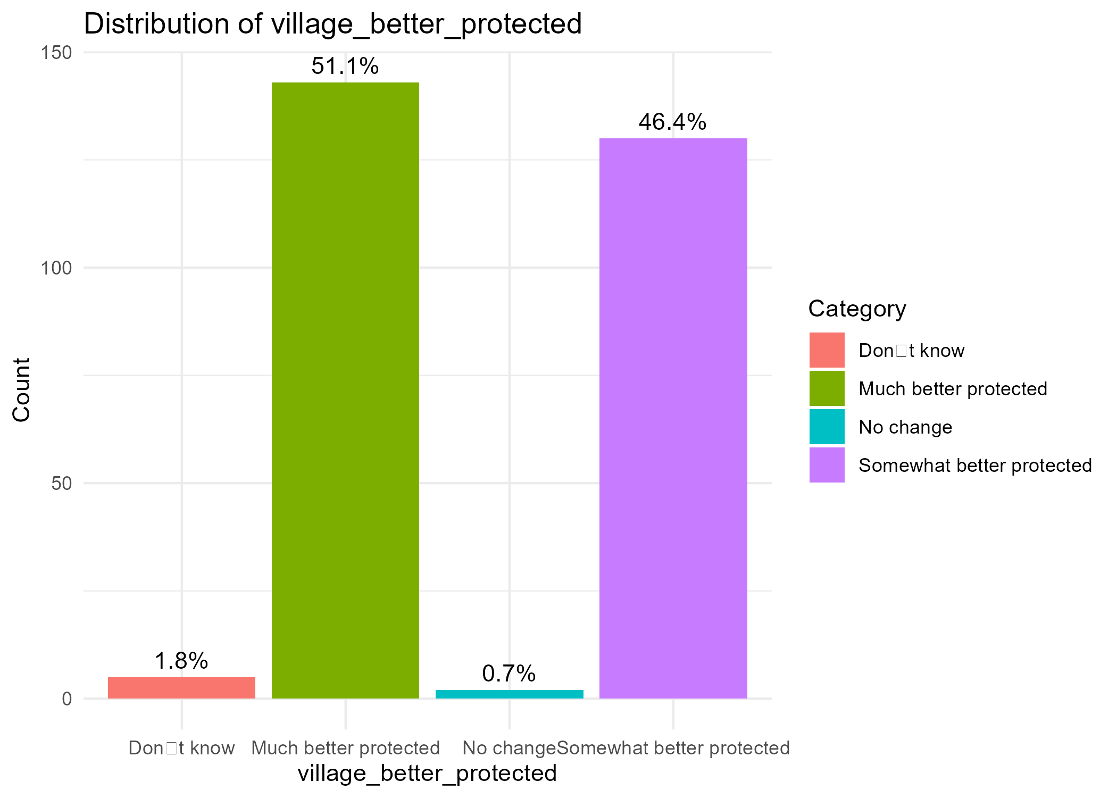
- 3.21 Which intervention has had the greatest positive impact on your life?
When asked to name the most impactful intervention, respondents highlighted:
- Improved sanitation facilities – 21 households (7.5%)
- Access to clean and safe water – 19 households (6.8%)
- Access to clean water – 13 households (4.6%)
- Good health – 8 households (2.9%)
- Hygiene education and training – 8 households (2.9%)
These results show that water access and sanitation facilities are perceived as the clearest benefits, closely followed by hygiene-related improvements.

- 5.75 Would you recommend a similar project be implemented in another village? ☐ Yes ☐ No ☐ Not sure. Why/Why not? ____________________________________________

- 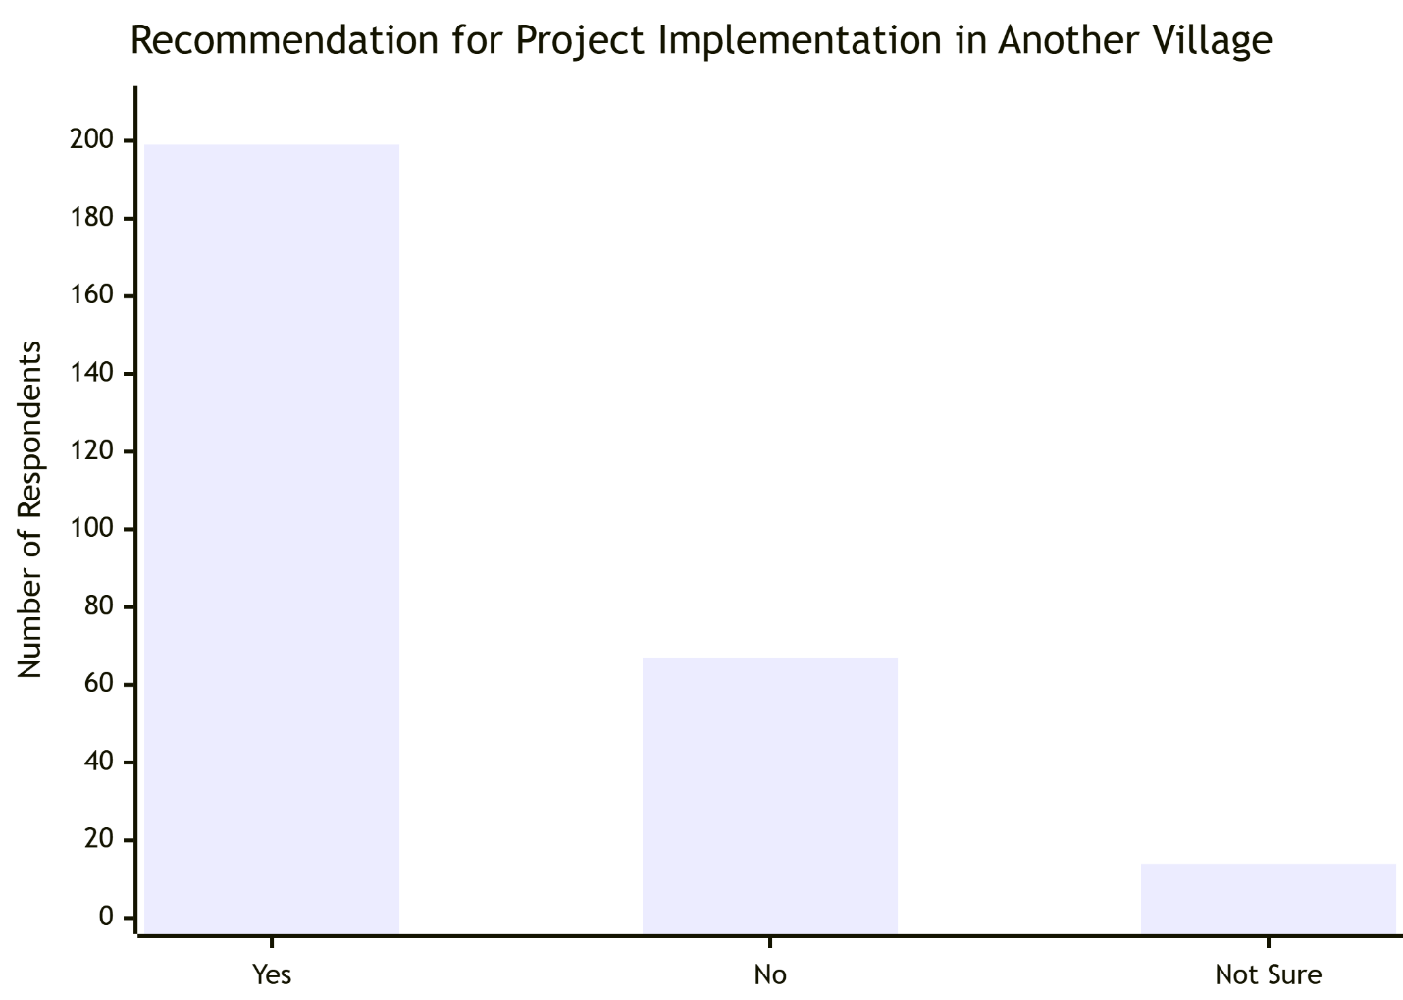

Response | Count | Percentage
Yes | 199 | 0.711
No | 67 | 0.239
Not sure | 14 | 0.05
Total | 280 | 1
- The vast majority of respondents (199 out of 280) would recommend the project to other villages. This is a strong endorsement of the project's impact, design, and value. It suggests that the benefits experienced by this community are perceived as transferable and highly needed elsewhere.

- SUSTAINABILITY
Will the benefits of the project continue after external support ends?
- 4.31 Is the Solar-Powered Borehole Functional? ☐ Yes ☐ No (Reason: _________________________)

- 4.32 Do you experience water shortages or breakdowns in the system? ☐ Yes ☐ No. If yes, how often do you experience breakdowns of the water system? ☐ rarely (once every few months) ☐ frequently (monthly or more)
- 60% of households overall reported experiencing borehole/kiosk shortages or breakdowns in the past year.
- Among those reporting, 99% said breakdowns were rare (only once every few months), while less than 1% cited frequent breakdowns.
While breakdowns do occur, they are generally infrequent and manageable, showing a robust but not flawless system.

- 4.35 Are user fees for water or sanitation services being collected and used effectively in your community? ☐ Yes ☐ No ☐ Don’t know ☐ Not applicable

Yes (for water services), from the analysis, user fees for water from HFHK kiosks are being collected consistently and are considered affordable, indicating effective daily operation. There is no mention of user fees for sanitation services.

- 4.36 In your opinion, can the community manage and sustain these services without external support? ☐ Yes ☐ No ☐ Not sure ☐ Only with partial support

Only with partial support. The community has demonstrated the ability to manage daily operations and collection of small fees. However, the low income levels and the technical nature of maintaining solar-powered water systems suggest that major repairs or large-scale canal maintenance would require financial or technical assistance from an external partner.
- 4.57 Is there a community committee that maintains the canals in your area? ☐ Yes ☐ No ☐ Not sure. If yes, is the committee still active? ☐ Yes ☐ No ☐ Don’t know
- 7.76 Do you believe the water and sanitation improvements will last? o Yes, with community effort o Only with external support o No. If no give reasons……………………….

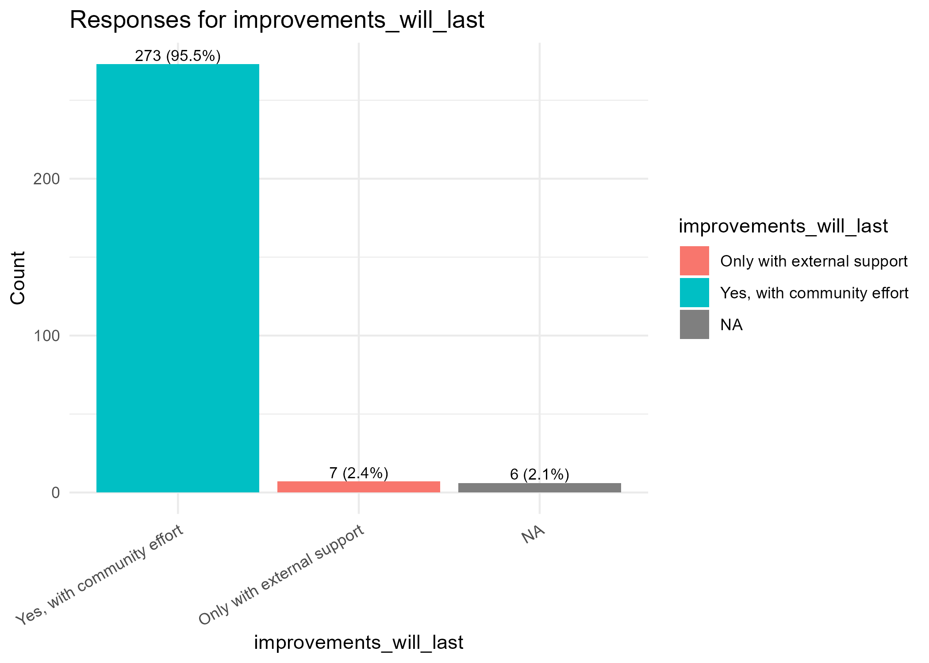
- 7.77 Are there systems in place for maintaining the borehole/kiosks? o Yes, a clear maintenance plan o Some efforts, but inconsistent o No system

Response | Frequency | Percentage(%)
Yes, a clear maintenance plan | 230 | 0.821
Some efforts, but inconsistent | 44 | 0.157
No system | 6 | 0.021
Total | 280 | 1

The vast majority (82.1%) confirm the presence of a clear, formal maintenance plan. This is a critical success factor for sustainability and explains the high confidence in Question 7.76. The 15.7% who report inconsistent efforts highlight that while the structure exists, ensuring consistent follow-through is an ongoing challenge that requires continued support and monitoring.
- 7.78 Would your household be willing to pay more for water to sustain the system? o Yes, at current rates o Yes, but only if cheaper o No
Response | Count | Percentage
Yes, at current rates | 159 | 0.568
Yes, but only if cheaper | 103 | 0.368
No | 18 | 0.064
Total | 280 | 1

- Positive Signal - A combined 93.6% of households are willing to pay for water, which is an excellent indicator for financial sustainability.
- Price Sensitivity - However, there is significant price sensitivity. While 56.8% are willing to pay at the current rate, a further 36.8% would only pay if it were cheaper. This suggests that the current rate is at the upper limit of affordability for a large segment of this low-income community. Any future cost increases for major repairs could challenge the system's financial model.

- 7.79 Has the project strengthened community cohesion in managing WASH services? o Yes o Somewhat o No
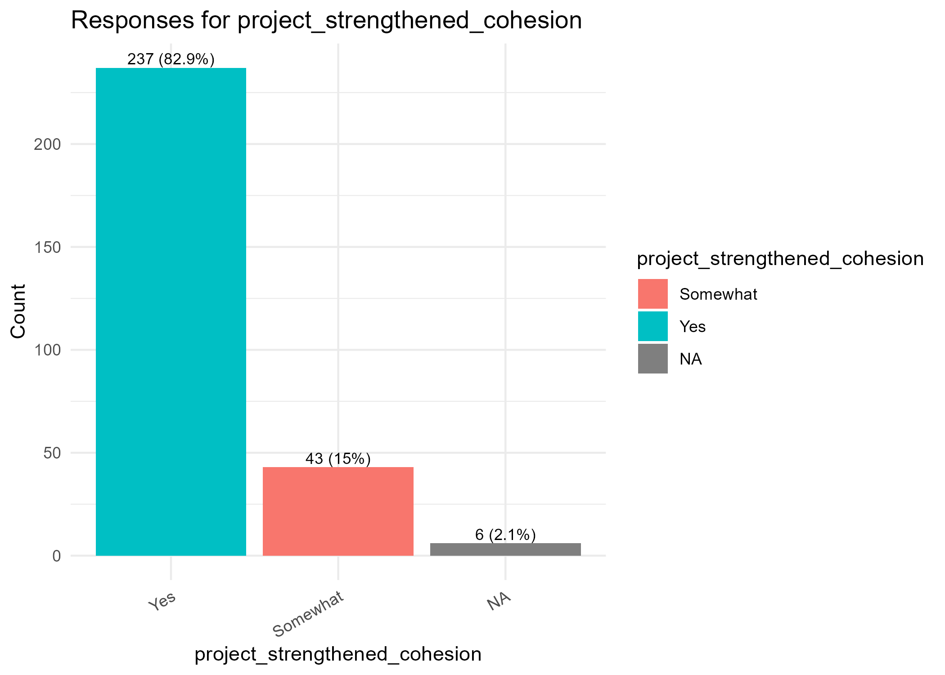

LESSONS LEARNED
What worked well and what could be improved for future projects?
- 3.20 [If NO to Q18:] Why do you think the interventions are no longer useful? (Open-ended)
Open-text responses show very limited critique of HFHK interventions. The only recorded reason was from a respondent who stated “He doesn’t use them” (100% of valid responses). This suggests that dissatisfaction is more related to lack of uptake rather than failure of the interventions themselves.

- 3.22 What challenges still remain in water, sanitation, or flood protection?
  - The main recurring challenge is the demand for more canals:
- “More canals are required” – 13 mentions (4.6%)
- “Are not enough” – 8 mentions (2.9%)
- “Can’t access due to long distance” – 6 mentions (2.1%)
- “Lack of handwashing materials” – 5 mentions (1.8%)
- “Lack of enough water kiosks” – 4 mentions (1.4%)
This indicates that while HFHK interventions are appreciated, infrastructure gaps remain, particularly around water distribution systems and handwashing support.

- 5.71 Were there any project activities that you think were unnecessary, too expensive, or could have been done better? ☐ Yes ☐ No ☐ Not sure. If Yes, please explain:

Response | Count | Percentage
No | 218 | 0.779
Yes | 21 | 0.075
Not Sure | 41 | 0.146
Total | 280 | 1

Most respondents (77.9%) saw no major flaws, aligning with the high efficiency scores. However, those who did cite issues ("Yes" and qualitative responses) point to:
- Quality of Construction: "Latrines were poorly constructed," "Houses were not built properly."
- Incomplete Coverage: "All canals were not desilted," "Extension of water pipes could be done better."
- Administrative Issues: "The payment delay."

- 5.75 Would you recommend a similar project be implemented in another village? ☐ Yes ☐ No ☐ Not sure. Why/Why not? ____________________________________________

Response | Count | Percentage
Yes | 199 | 0.711
No | 67 | 0.239
Not sure | 14 | 0.05
Total | 280 | 1
The vast majority of respondents (199 out of 280) would recommend the project to other villages. This is a strong endorsement of the project's impact, design, and value. It suggests that the benefits experienced by this community are perceived as transferable and highly needed elsewhere.

